PHYSICAL CARE OF AN INFANT
Read the listed pages and fill in the blanks to complete the notes.
Handling a Newborn (p.238-239)
- Babies constantly need to be picked up for reasons that are both ___________________and ________________________
- They must be handled gently and carefully because they do not have the same __________ control or ______________ strength as an older baby
- You must ALWAYS _________________ the baby’s head and neck when lifting
- To lift baby: slide one hand under the bum and the other under the shoulders and neck.
- Remember to move slowly and carefully so that you do not ____________________ the baby
Comforting a Crying Baby (p.270-271)
- A baby crying needs ___________________ and care
- The parent should first check for any ________________ problem (ex. Hungry? Diaper? Too hot/cold? Burp?)
- If all physical needs are met, the baby may simply need emotional _____________________
- Successful comforting strategies vary between different children. Here are some examples:
  - ________________ up with the baby in a rocking chair to provide a feeling of closeness and movement
  - Move the baby’s position
  - Talk or sing softly to baby
  - Offer a __________________________ (ex. Toy)
  - Place baby face-down on lap and rub the baby’s back
- Baby’s may also ________________________ (ex. Pacifier, thumb-sucking, comfort item, etc)

FEEDING AN INFANT (p. 240-246)
Feeding Schedules
- Newborns do not have __________________- schedules at first
- They should be able to eat when they want and as much as they want
- Because of the size of their stomach, newborns eat _______ times a day in the first few weeks
- As they get older, their feeding patterns become more predictable and feeding becomes ___________ frequent because the stomach can hold more
Breast Feeding
- Breastfeeding promotes good health in both the mother and infant
- New mother’s should take advantage of the help they are provided in the hospital to learn how to breastfeed
Bottle Feeding
- Always wash hands and _____________________ bottles and water before preparing a bottle
- Bottles should be warmed slightly but temperature should always be checked on the inside of the wrist before being given to baby.
- When feeding a baby a bottle, the baby should be held close, in a ______________________ position and the head should be _________________ the level of the bottle
- Keep the bottle on an ________________ to make sure that the nipple stays full of milk
- Sucking in too much air can cause ______________ and discomfort for the baby
Burping
- Whether breast feeding or bottle feeding, a baby should be burped at least ____________ per feeding
- This allows the baby to expel any air that has been ingested while feeding
- To burp a baby, hold them either __________ or across your ____ and pat baby’s back gently
Introducing Solids
- Babies usually begin on solids around __________ months of age
- Solids are introduced in combination with breast or formula feeding
- Signs of readiness include: ability to sit up with support and keep head steady, showing interest in your food, etc)
- The first solid introduced is typically rice ______________ – it should begin as an almost ______________ consistency and gradually become more solid as baby adjusts
- New foods should be introduced every ___________________ days so that the baby can be watched for signs of allergy – this helps to determine what foods the baby has sensitivity to

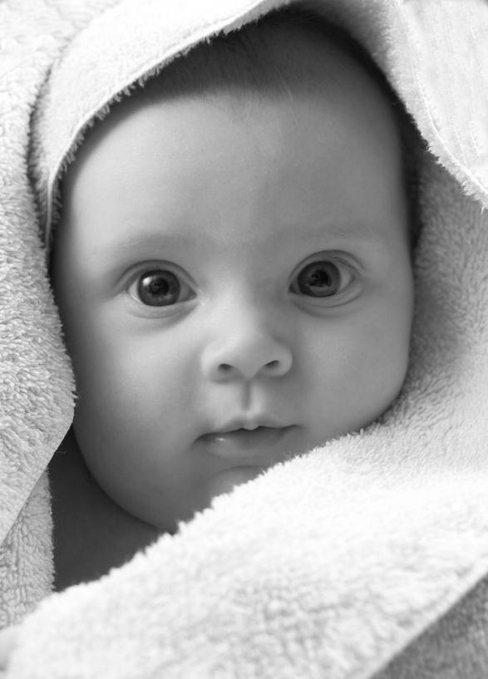
Bathing an Infant (p.247-249)
- Never leave a baby unattended in the bath
- Have all supplies prepared and within arms reach
- Make sure the room is ______________
- Fill the infant tub with only 1-2 inches of water
- Test the water temperature with your ________________
- Make sure you have a non-slip mat or small towel in the base of the tub so that the baby doesn’t slide
- Always _____________________ the infant with one hand
- Use a gentle (odour and dye free) wash to clean baby
- Start with the cleanest part of a baby’s body (the _______) and work toward the baby’s bottom last
- Never use Q-Tips inside baby’s ears!
Sleep (p.256-259)
- A newborn will sleep anywhere from 12 hours per day to 20 hours per day
- By one year, a baby typically has _______________ sleep periods including naps
- Active babies tend to sleep ___________ than inactive ones and also need more __________
- It is good to follow a similar _________________ each night so that the baby learns the ______________________ for bed time
Diapers (p.253-254)
- Two options: ___________ diapers or __________________ diapers
- Often, a newborn needs it’s diaper changed _____ to _____ times each day (frequent diaper changes can help prevent diaper rash)
- Keep diaper supplies organized and within reach at a sturdy and padded changing area
- Remember that it is never _________________ to leave a baby alone on a changing table or other raised surface
- Follow these steps:
  - Remove the diaper and clean the baby (always wipe from front to back)
  - Put on a fresh diaper
  - Dispose of used supplies

Dressing a Baby (p.250-253)
- When dressing a baby, think about the _______________ temperature rather than the weather
- Typically, a baby should be dressed similarly to an adult in terms of warmth – some say they should be wearing one layer more than an adult
- To check a baby’s temperature, feel the back of the __________ for clamminess as a sign that the baby is overheated or the arms and legs to see if the baby seems too cool
- It is not accurate to assess a baby’s temperature by feeling their ___________ and _________ as they are almost always cool
- Although it is fun to dress a newborn, their clothing needs are minimal
- A newborn can get away with simply having _________________ in their closet
- Shoes are _____________________ for infants as they are often kicked off and even as the child gets older, they are not needed until he/she is able to walk _______________________
- When choosing clothing for an infant, think about __________________ and ease in dressing
- Always be gentle when pulling baby’s arms and legs through clothing
- Make dressing the baby an interactive process
Infant Car Seats (p.188)
- The use of car seats for infants is mandatory
- The safest place for an infant car seat is in the back seat of the car because of airbags
- Rear-facing car seats are used for infants who are less than ______ pounds or less than _________ inches in height
- Babies are strapped into the car seat using a 5 point _________________
- The bucket seat clicks into a base in the car which is held in place by a universal anchorage system
- The seat should be adjusted so that the baby is in a ______________________ position
- Babies can move to forward-facing car seats after they reach one year but new research states that it is recommended that they stay rear-facing until they reach 30 pounds
Home Safety (p.486-489)
- The safety of a child is the most important ____________________ of the parent or caregiver
- __________________ represent the most serious threat to infants and their safety
- To keep a child safe, the following knowledge is required:
  - Knowledge of child development
  - A safe environment
  - Alertness to safety hazards
  - And teaching a child safe habits
- Remember: a toddler should never be left _________________ for more than a few minutes and even then, they should be within ___________________ distance
- Hazards to infants and toddlers include: ingesting poisons, choking, water, falling off furniture or down stairs, climbing unsecured furniture, electrical outlets, cords, chargers, plants, etc

