**WELCOME TO THE WORLD**

You are going to make a booklet with as much information about your birth and early childhood as possible.

**THE BIG DAY:**

* Place of birth, city, hospital etc,
* Time of birth: what kind of day was it, what was the weather like, any historical events at this time
* Where were your parents when labour began?
* How long was the labour?
* C:\Users\Debali\AppData\Local\Microsoft\Windows\Temporary Internet Files\Content.IE5\BQEHS9IW\MCj04260360000[1].wmfWho was present at your birth? Family, medical persons etc.
* Was it video taped?
* Any unusual happenings?

**JUST THE FACTS:**

* What were your measurements?
* Weight at birth?
* What’s your full name? What is the meaning of it? How did your name get chosen?

**HOME SWEET HOME:**

* 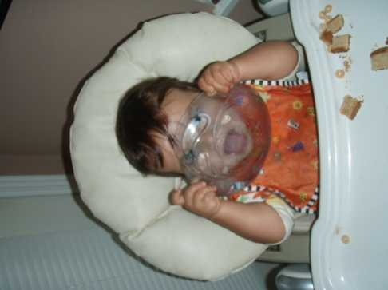Where did you live? Did you have your own room? How was it decorated?
* Where did you sleep?
* How did brothers and sisters react? Pets?
* What was the first year like? Be specific...get as much detail as you can!

**SPECIAL MOMENTS:**

* What were your first words?
* When did you first roll over? Sit up? First step? First tooth?
* Favourite foods
* Special toys, blankets etc.
* Favourite books? Songs?
* Favourite things to do?

Ask questions that you would like answered about your birth and early childhood. What sources of information are available to you? Baby books, videos, family records, albums, traditional stories etc.

If you are adopted, this will have to be modified to include what information you can find about your birth as well as after being adopted.

* What was it like the first time they met you?
* How long did they know you before you came to live with them?
* What was it like when you first came home with them?
* What were the first six months like?
* What information do they know about your past?

**PRESENTATION:**

* Cover
* 4 pages minimum with **titles**
* Neatly and computer generated if writing is messy
* Include pictures and photographs where possible
* Embellish with appropriate graphics
* Organization of information

**WELCOME TO THE WORLD**

**Evaluation**

**PRESENTATION**

* Cover/assembled as a booklet
* Neat/computer generated
* Pictures/embellishments included on each page
* Title and content included on each page

**PAGE 1 - THE BIG DAY**

* Place of birth
* Time of birth
* Where were parents when labour began
* How long was the labour
* Who was present
* Unusual happenings?

**PAGE 2 - JUST THE FACTS**

* Measurements? (weight, length, head circumference)
* Full name
* Meaning of name?
* How was name chosen?

**PAGE 3 – HOME SWEET HOME**

* Where did you live?
* Own room?
* What did you sleep in?
* Sibling reactions
* How was the first year?

**PAGE 4 – SPECIAL MOMENTS**

* First words
* Milestones (roll over, sit up, first steps, first tooth?)
* Favourite food
* Special toys/blanket/book?

|  |  |  |  |  |
| --- | --- | --- | --- | --- |
| **DOES NOT MEET EXPECTATIONS/**  **CRITERIA established for this assignment** | **MINIMALLY MEETS**  **EXPECTATIONS/**  **CRITERIA**  **established for this assignment** | **PARTIALLY MEETS EXPECTATIONS/**  **CRITERIA**  **established for this assignment** | **FULLY MEETS EXPECTATIONS/**  **CRITERIA**  **established for this assignment** | **EXCEEDS**  **EXPECTATIONS/**  **CRITERIA**  **established for this assignment** |
| **NHI I**  **0-45%** | **C- C**  **55% 60%** | **C+ B-**  **70% 73%** | **B B+ A-**  **78% 82% 86%** | **A A+**  **92% 100%** |