SAFE SEX/TEEN PREGNANCY CAMPAIGN
You will be designing a campaign that calls attention to the responsibilities and realities of teen parenthood. Your purpose is to inform your peers about what life as a pregnant teen/teen parent is really like. You may design your campaign as a poster, a PowerPoint, or as a commercial/public service announcement (PSA).
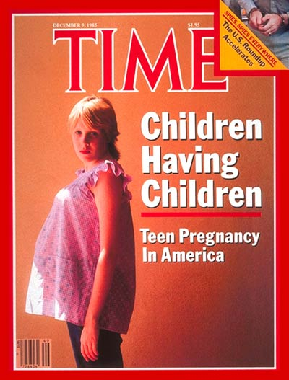

PROCEDURE:
- Determine the message you want to convey to teens – would you like to focus on safe sex, the realities of teen pregnancy, or teen parenthood?
- Come up with a catchy slogan that is original to you to convey the message. DO NOT GOOGLE! What will make your slogan memorable? Rhyme? Song? Humour? Eye-opening? Impactful?
- Use key facts and statistics relating to teen pregnancy/parenthood to support your slogan and emphasize its importance (find these statistics and information in your text, from worksheets provided in class, from our experience talking to teen moms, or from the media).

Due Date: _____________________
EVALUATION:
(Please hand this sheet in prior to presenting for marking)
Slogan/Statistics:
- Originality of slogan
- Easy to understand/Makes sense
- Impact
- Memorability
- 5 related statistics included

Design, Visual Impact & Creativity:
- Eye catching/Bold
- Images & words included
- Creativity
- Neatness

Use of Class Time:
- Resourceful & Productive
- Spelling/Grammar/ Completed with care
- Asked for assistance when needed
- Submitted on time

DOES NOT MEET EXPECTATIONS/  CRITERIA established for this assignment | MINIMALLY MEETS  EXPECTATIONS/  CRITERIA  established for this assignment | PARTIALLY MEETS EXPECTATIONS/  CRITERIA  established for this assignment | FULLY MEETS EXPECTATIONS/  CRITERIA  established for this assignment | EXCEEDS  EXPECTATIONS/  CRITERIA  established for this assignment
NHI I  0-45% | C- C  55% 60% | C+ B-  70% 73% | B B+ A-  78% 82% 86% | A A+  92% 100%

