APPROPRIATE Meme Assignment

Since memes are a daily part of your life, I thought we can channel that knowledge and use it for education.

Instructions:
You are to create at least 4 appropriate memes. Maximum of 10 but minimum of 4.

Part 1
2 appropriate educational memes. These memes are somehow educational or promoting good habits in the classroom like wearing safety glasses and putting tools away properly. These should be encouraging good practices/behavior in the classroom, think of them like safety posters that are around the class. There are some examples at the end of the document.

Part 2
2 appropriate funny memes: These can be a funny (appropriate) reference to our classroom.

Part 3 - Optional
You can create up to 6 more appropriate memes. You can choose to make them funny or education or a mix. Just don’t forget that they have to be appropriate.

Part 4 - Submitting your Work
Make a word document and place your memes into it. You should do one per page and label them as either Educational/Habit forming or Funny.

You can use this website for templates. https://imgflip.com/memegenerator

Examples are below.

Educational/Habit forming meme
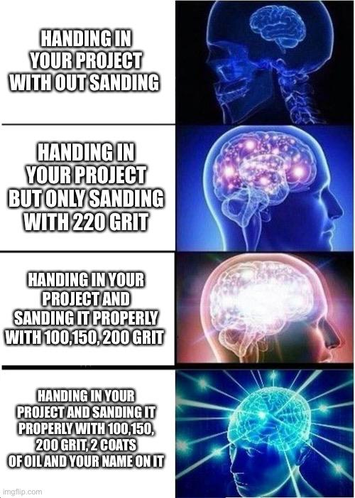

More below

Educational/habit forming meme

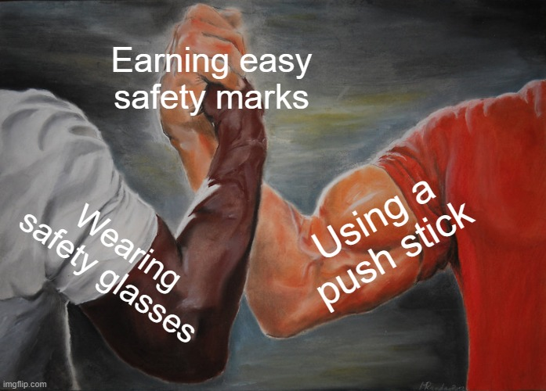

More below

Educational/Good habit forming meme
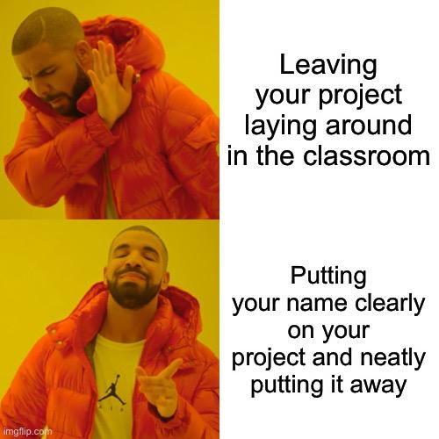

More below

Funny classroom related meme
Funny classroom related meme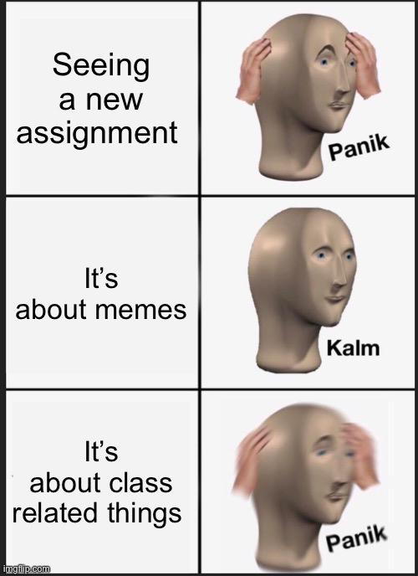

Funny classroom related meme
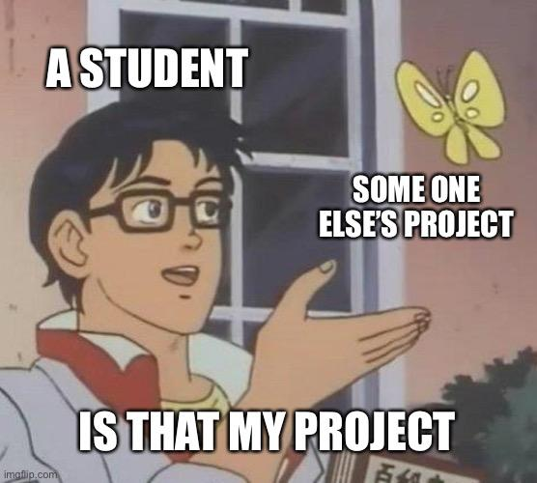

More below

Funny classroom related meme

