
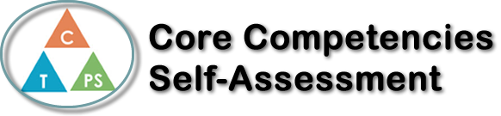
Name: Ainsley | Date: June 3, 2020

  How does the artifact you selected demonstrate strengths & growth in the communication competency?  In what ways might you further develop your communication competency? | Self-Reflection  Describe how the artifact you selected shows your strengths & growth in specific core competencies. The prompt questions on the left - or other self-assessment activities you may have done - may guide your reflection process.  I would like to focus on my Personal Awareness and Responsibility – Self Regulation core competency. This course has challenged me to learn how to type without looking at the keyboard and improve on my writing skills. As well as, my typing speed and accuracy.  During this time of social distancing and self isolation, it has been hard to adjust to my new learning environment and the style of learning. Working from home has required me to be more responsible with my work. Every Monday at 12:30 pm we have a class meeting to discuss that week’s agenda. To remember that I have a meeting, I set an alarm and put a reminder in my phone, that way I don’t get marked absent. Throughout this course I have always completed my work on time. Now with this new learning style, we are given our assignments at the beginning of each week and have a week to two weeks to complete them. I absolutely love this method because I like to work at my own pace. Typically, I complete all the assignments within 2-4 days. This class was a very easy transition to the new learning approach, since this class is online based. Overall, I am finding this class easy and I am very pleased with the marks I am receiving!


How does the artifact you selected demonstrate strengths & growth in the thinking competencies?

In what ways might you further develop your thinking competencies?

X

How does the artifact you selected demonstrate strengths & growth in the personal & social competencies?

In what ways might you further develop your personal & social competencies?

Publish Your Self Assessment
You will now attach and/or embed your self-assessment to the bottom of the blog post with the artifact you have chosen. You may choose to make this post private or public. After placing your artifact on a blog post, follow the instructions below.
- Categories - Self-Assessment
- Tags - Now tag your post using the tag that corresponds to the competency that you have written about. You can choose more than one. Please use lower case letters and be exact.
  - #creativethinkingcc
  - #communicationcc
  - #criticalthinkingcc
  - #socialresponsibilitycc
  - #personalidentitycc
  - #personalawarenesscc
- Use the Add Document button located at the top of your post page and embed your self-assessment at the bottom of your blog post.
- Publish

