
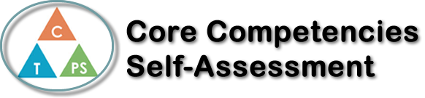
Name: Ainsley Enos | Date: December 3, 2019

  How does the artifact you selected demonstrate strengths & growth in the communication competency?  In what ways might you further develop your communication competency? | My artifact is my weekly buddy visit to Central Elementary School. In Human Behavior we get to work with the grade 4 and 5 students. We work with two classes and I have one girl buddy and one boy buddy.  This experience has helped me improve communication skills. Going to buddies every week you have to be able to communicate with your buddy and be able to learn how they work best or what they struggle with. I have to think about what my two buddies may be interested in talking about, which can be hard at times because of the age difference and we are all interested in different things.  Both of my buddies have different personalities, one is extremely outgoing and talks a lot whereas the other one is a little bit shy and struggles with spelling. I try my very best to help my buddy with spelling so her grammar/spelling skills can improve because that is one of her goals. Over the span of these few months, I have got a better understanding of my buddies, what they enjoy and what makes them laugh. With my girl buddy, we are actually neighbors, so she is pretty comfortable around me. I am an aunt and being an aunt actually helps me with communicating with other kids. Each week one of the high school buddies has to plan the buddy activity, and this has helped me with my creativity and planning abilities.


How does the artifact you selected demonstrate strengths & growth in the thinking competencies?

In what ways might you further develop your thinking competencies?


How does the artifact you selected demonstrate strengths & growth in the personal & social competencies?

In what ways might you further develop your personal & social competencies?

Publish Your Self Assessment
You will now attach and/or embed your self-assessment to the bottom of the blog post with the artifact you have chosen. You may choose to make this post private or public. After placing your artifact on a blog post, follow the instructions below.
- Categories - Self-Assessment
- Tags - Now tag your post using the tag that corresponds to the competency that you have written about. You can choose more than one. Please use lower case letters and be exact.
  - #creativethinkingcc
  - #communicationcc
  - #criticalthinkingcc
  - #socialresponsibilitycc
  - #personalidentitycc
  - #personalawarenesscc
- Use the Add Document button located at the top of your post page and embed your self-assessment at the bottom of your blog post.
- Publish

