What direction should the BC Forestry Industry take?

In BC we currently are using forestry practices such as clearcutting, silviculture and selective logging. You are probably wondering what these are? Clear-cutting is the process of cutting down all trees in an area of a forest at once. This can greatly impact wildlife and their habitats. Silviculture is the art and science of controlling the establishment, growth, composition, health, and quality of forests to meet the needs and values of landowners and wildlife. Silviculture is also used to manage forests for wildlife or water or recreation. Selective logging is the practice of cutting down one or two types of trees while leaving the rest standing.
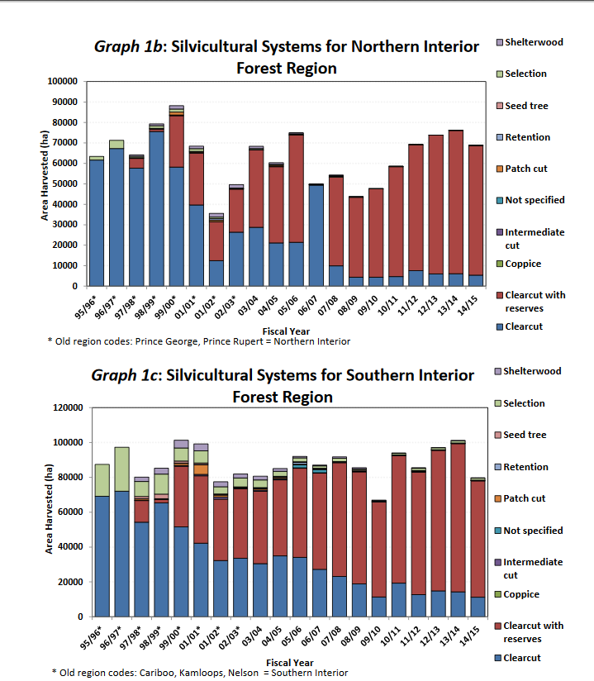
I looked at a PDF with statistics on Silvicultural Systems and the most used practice is clearcutting and clearcutting with reserves.
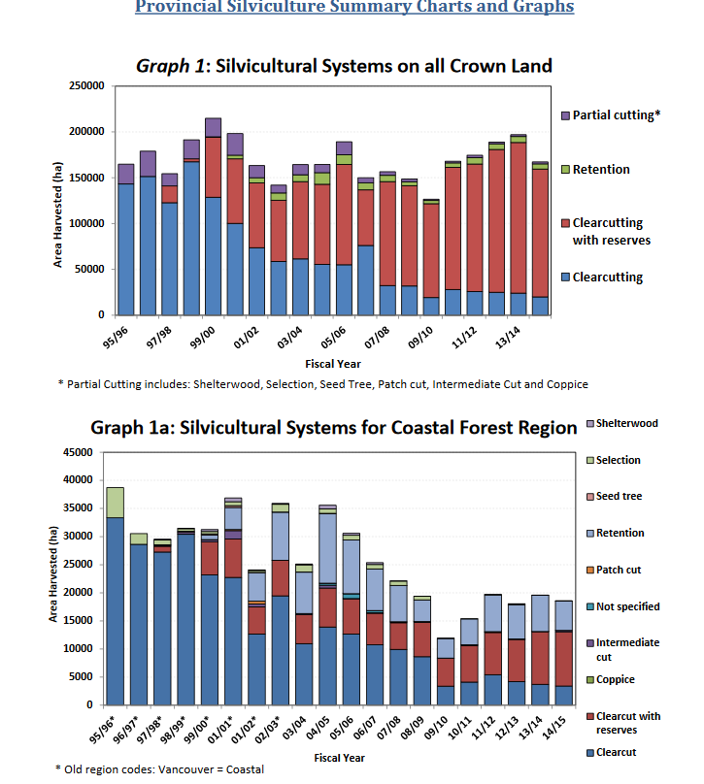
Our economy is something that is essential to us and it needs to continue running. Depending on what country you live in you need to make use of your surroundings in order to sustain your economy. I think the BC forestry industry needs to slow it’s process down because if we keep clearcutting trees then we will start to run out of them and will not be able to create enough materials and keep a stable economy. As well as, clearcutting takes a major toll on our environment and wildlife that live in those areas. In that case, the government should plant some of those trees back. We should be trying to use Silviculture more often because it helps regenerate forests after deforestation occurs but at a more rapid speed.

