Foods 12 Ainsley
October 5, 2018
September Reflection

The lab I chose to reflect on for the month of September was the Sunflower Crepes. Sunflower crepes are a savory breakfast dish, where you form the crepes into a bowl/sunflower shape and you put cheese, eggs, green onions and bacon in them, then you cook them in the oven.
I chose to reflect on this lab because I have never made crepes before, as well as I have never heard of savory crepes, so I thought it was a unique and cool idea. Now, that I have made these, I might think of making them at home since my Mum enjoys crepes.
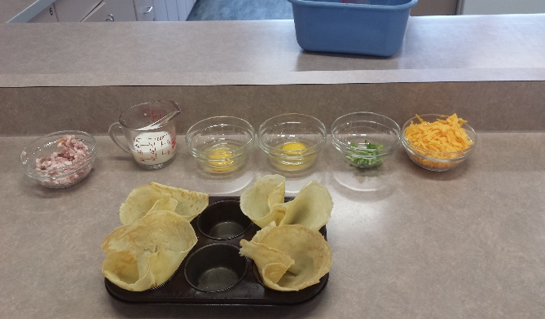
I enjoyed this lab and my group, and I worked very well together. Once we got started we got one person to cut the bacon, another person to cut the green onions and another person to sauté the bacon. There was one difficulty during the lab, which was getting the crepes out of the muffin tin. We had to be extremely careful when taking the crepes out because if we didn’t they would tear, and all the filling would ooze out. Most of our crepes were stuck to the bottom of the tray causing them to rip, which made them look like an egg explosion instead of a sunflower, only one out of four of our crepes turned out like a sunflower. If I were to do this lab, I would probably add different ingredients and I would also probably find a solution to the crepes not sticking to the muffin tray. Overall, this was a good lab and I enjoyed working with my group.
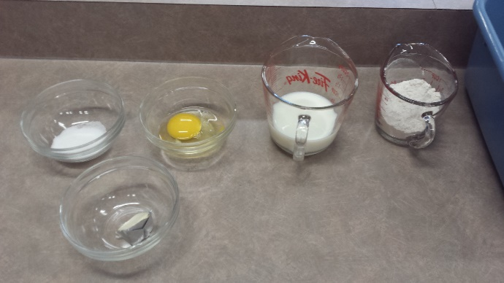

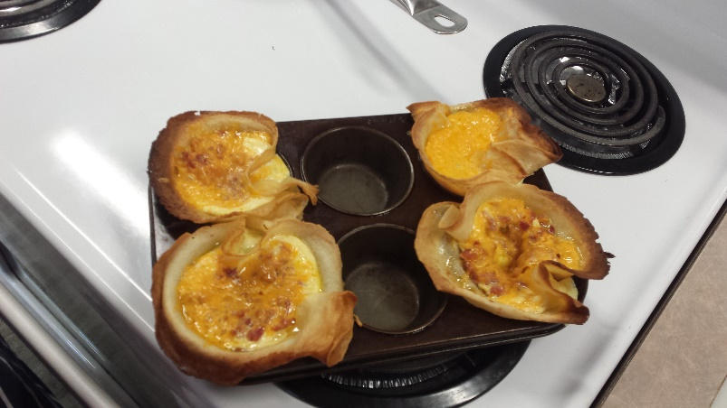
This is an image of my Mise-En-Plus for the ingredients in the crepes.
This is an image of our final product.
This is an image of my Mise-En-Plus for the crepe dough.

