Psychology 12 Ainsley
Oct 15, 2018
Neuro Communication Lesson

To start, neurons are cells that transfer information. Neurons are made up of a cell body, which is pretty important because it is the cell’s life support center. There is an axon and their messages are carried to other cells and are carried away from the cell body. The nucleus; is inside of the cell body, dendrites receive information from other neurons, and sensory receptors. The myelin sheath covers the axon of some neurons and it helps to speed neural impulses. The final part that makes up a neuron are the axon terminal buttons, which form a bond with other cells.
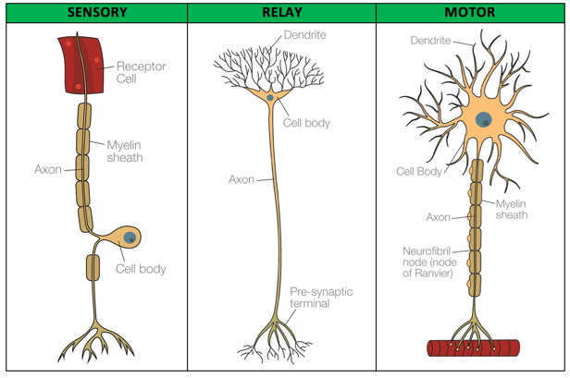

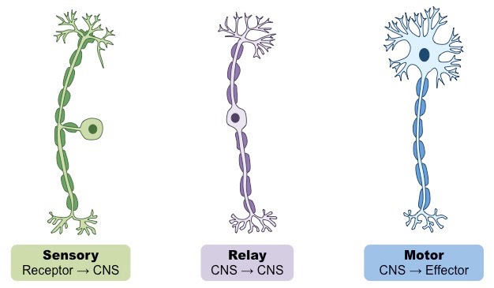
There are three different types of neurons, they are the motor neuron, the sensory neuron, and the interneuron (relay neuron). A motor neuron is a neuron that passes from the central nervous system that conducts impulses outwards from the brain and spinal cord. A sensory neuron transmits nerve impulses from a sense organ towards the central nervous system. Interneuron or a relay neuron transfers signals between neurons. However, they are only found in the brain and spinal cord.

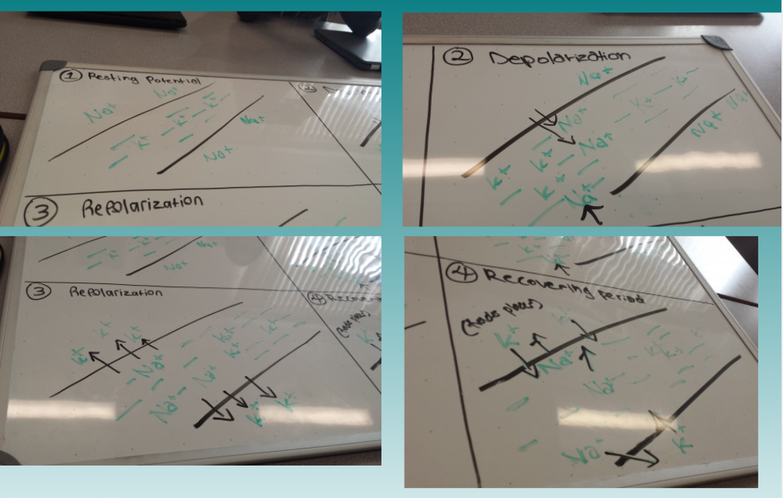
A neuron has action potential, which means it can move across the neuron fiber. There are four stages to Action Potential, including the resting stage, depolarization, repolarization and the flow of depolarization or recovery phase.
The resting stage is where there are more positive ions (sodium) than negative ones on the outside, although there are more negative ions in the center (potassium). If there are more positive ions outside, then the inside of the axon would be negative, approximately -70mv. During depolarization, the axon opens its “doors” and the positively charged sodium ions go through and travel to the center. The additional sodium ions change the previously negative charge that was inside to a positive charge. During repolarization, some of the positively charged potassium ions travel back to the outside of the axon. Lastly the flow of depolarization or also could be called the recovery phase, causes action potential to move frequently down the axon. The potassium and sodium ions trade places. This means that the potassium ions go back into the center and the sodium ions travel back to the outside of the axon.
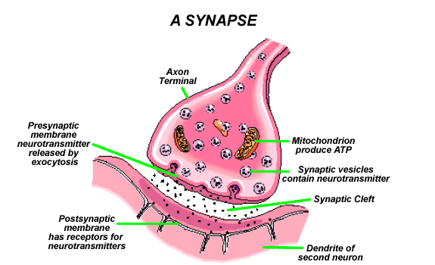
A synapse is a bond between two neurons. If you were to label the synapse on a diagram, then it would be the space between the presynaptic membrane of the axon and the post synaptic membrane of the dendrite. A synapse includes tips of terminal branches of the axon, tiny spaces between neurons, and ends of dendrites of receiving neuron (receptors). Firstly, the action potential must reach the axon terminal, however, the action potential causes synaptic vesicles to release neurotransmitters into the synaptic gap. Later on, the neurotransmitters spread through the gap and attach to the receptors on the receiving neuron. Neurotransmitters messages are received as excitatory or inhibitory.

Photo Creds: https://www.tutor2u.net/psychology/reference/biopsychology-sensory-relay-and-motor-neurons
http://ib.bioninja.com.au/_Media/types-of-neurons_med.jpeg
https://14yunhyu.files.wordpress.com/2013/12/synapse_1.gif

