Exploring quadratic functions (7.1)
Follow the instructions laid out in this worksheet and post your answers in a blog post. Use www.desmos.com to answer the questions below.
Due: Wednesday Sept 26th
Title: Exploring quadratic functions
Categorize: Math 11
Tag: quadratics, pahlevanlu
- Find and write the definition of a quadratic function in words you understand. (use your textbook, google, etc)
- Quadratic Function: A quadratic function is in the form of f(x) = ax² + bx + c, where a, b, and c are numbers that are not equal to zero. When this type of equation is graphed on a coordinate plane it makes a U Shape called a parabola. Parabolas may open upward or downward and vary in "width" or "steepness", but they all have the same basic "U" shape.

- Give an example of a quadratic function and give an example of a function that is NOT a quadratic.
Quadratic Function: Y= 10x² + 15x + 2
NOT a Quadratic Function: Y= 9x-4

- Go to desmos.com and type in the following function: $y=ax^{2}+bx+c$
  - Desmos will give you the option of adding “sliders” for $a, b, c$ or all. Click all. This will allow you to change the values of $a, b, c$ to see how the graph changes.
  - Start with slider values $a=1, b=0, c=0$. Describe any symmetry you notice.

- The bottom of the line starts at zero. Both sides of the parabola are equal and run through the exact same points.
- Keep b = c = 0. Change the value of $a$:
  - $a<0$
    - Does the graph open up or open down?
The graph opened downwards.
    - Does the graph have a maximum point or minimum point?
The maximum point would be zero.
  - $a>0$
    - Does the graph open up or open down?
The graph opens upwards.
    - Does the graph have a maximum point or minimum point?
The graph would have a minimum point which would be zero.

  - $-1<a<1$
    - Is the graph narrow or wide?
The graph is wide.
  - $a>1 or a<-1$
    - Is the graph narrow or wide?
The graph is narrow.
- We call the maximum or minimum point $(x,y)$ of a quadratic function the vertex. Complete the following statements:
  - When $a$ is positive (positive/negative), the vertex is a minimum (maximum/minimum)
  - When $a$ is negative (positive/negative), the vertex is a maximum (maximum/minimum)

- Let $a=1$ and $b=0$constant. Use the slider to change the value of $c.$Describe how the graph changes as $c$changes.
The parabola goes up and down the y-axis. Once it goes down, it goes into the negatives, so the minimum would change. C represents the y-intercept, so when we change C’s values the y-intercept changes.

Roots are the solutions to the quadratic equation. The roots are found by looking at where the curve crosses the x axis (x-intercepts).
Adjust the sliders for a, b and c so you can get a curve that just touches the x axis (y=0).

Equation: Y= 3.5x² – 0.9x + 0

This quadratic equation has ONE solution.

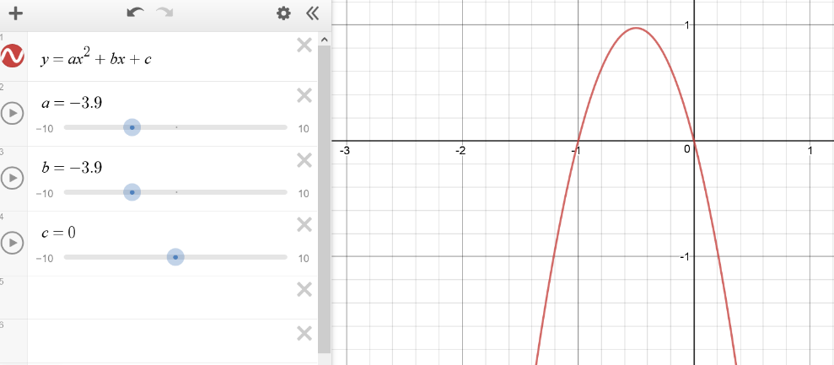
Adjust the sliders so you can get the roots of 0 and -1

Equation: Y= -3.9x² + 3.9X + 0

This quadratic equation has TWO solutions.

Adjust the sliders so that the curve does NOT cross the x-axis.

Equation: Y= 0.5x² -0.1x +10

When the curve does NOT cross the x-axis, there are NO REAL solutions for this equation.

