Foods 10 Ainsley
April 28, 2017
March/April Lab Reflection

Lab: Fettuccine Alfredo

Question: Why did you choose to reflect on this lab?
Answer: I choose to reflect on the Fettuccine Alfredo lab because I really enjoyed it and it tasted good (al dente). Also, it is something that my family and I have made at home, but at home we don’t make our own alfredo sauce, we use the canned stuff.
Question: Did you enjoy the lab? Why or why not?
Answer: Yes, I enjoyed this lab because it tasted really good, my group and I worked well together and it was something new and different that I’ve never made before.

Question: Did your product turn out the way you had hoped? If yes, what helped? If no, why did it not?
Answer: Our product turned out like we wanted it to but when we ate it, we realized the noodles were not fully cooked because some of them were hard not soft. But in the end it still tasted good.

Question: Did your group work well together during the lab? Why or why not? (i.e. were there any issues that came up/how did you solve them?)
Answer: Yes my group and I worked well together. We all contributed and helped out. For example, someone cooked the noodles, someone stirred the sauce and when their hand got tired someone else would take over and someone did the cutting.

Question: If you were to do this lab again, what might you do differently? Why?
Answer: If I were to do this lab again, I wouldn’t change much besides not putting as much garlic in and I would also test the noodles more often.

Mise- en- place
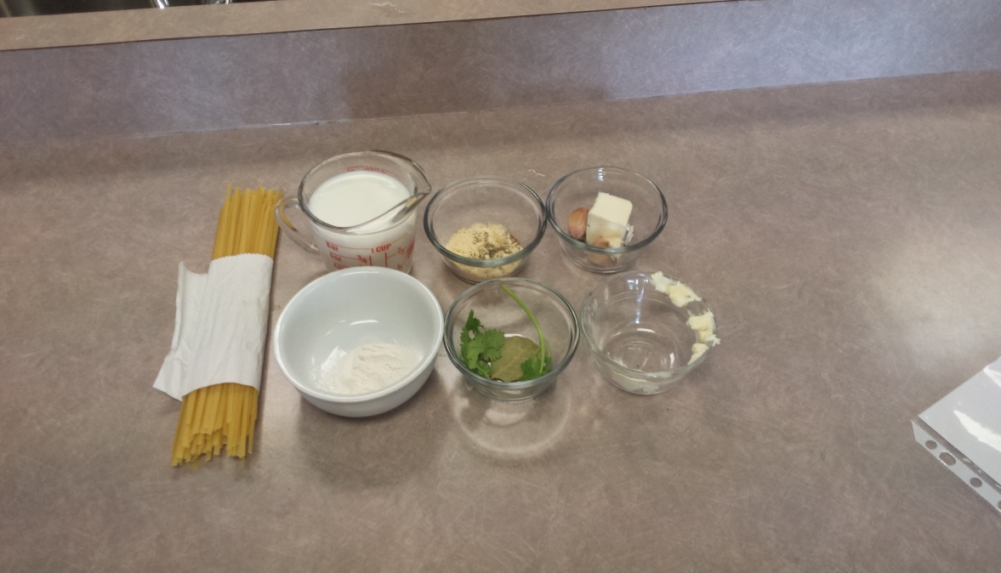

Final Product
