
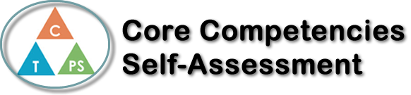
Name: Aiessa Magi Dela Cruz | Date: October 24, 2019

  x  How does the artifact you selected demonstrate strengths & growth in the communication competency?  In what ways might you further develop your communication competency? | Self-Reflection  Describe how the artifact you selected shows your strengths & growth in specific core competencies. The prompt questions on the left - or other self-assessment activities you may have done - may guide your reflection process.  Artifact: La Contaminacion en Bolivia powerpoint  How has this artifact improved your communication and critical thinking?  This artifact helped me improved my communication skills because I worked with a group in which communication is very crucial in this project because we need to collaborate and cooperate so we’re able to work more efficiently and make our project successfully be finished. Furthermore, I am a timid person however with this project, I improved with speaking in front of the class as I am slowly starting to be comfortable. Also, I feel like I am improving with communicating with my peers regarding on working on a project because I feel comfortable sharing my opinions and ideas with my groupmates which I think is very essential when there’s a group project. With regards to critical thinking, I was working on who is solving the air and water pollution, and I also needed to think of other ideas that can be helpful to solve pollution not only in Bolivia but in general for every place where there’s pollution. With this project, I improved on using credible sources that gives good information that is relevant to my research, as well as being able to make my points in PowerPoint brief enough and understandable to the viewers.

x

How does the artifact you selected demonstrate strengths & growth in the thinking competencies?

In what ways might you further develop your thinking competencies?


How does the artifact you selected demonstrate strengths & growth in the personal & social competencies?

In what ways might you further develop your personal & social competencies?

Publish Your Self Assessment
You will now attach and/or embed your self-assessment to the bottom of the blog post with the artifact you have chosen. You may choose to make this post private or public. After placing your artifact on a blog post, follow the instructions below.
- Categories - Self-Assessment
- Tags - Now tag your post using the tag that corresponds to the competency that you have written about. You can choose more than one. Please use lower case letters and be exact.
  - #creativethinkingcc
  - #communicationcc
  - #criticalthinkingcc
  - #socialresponsibilitycc
  - #personalidentitycc
  - #personalawarenesscc
- Use the Add Document button located at the top of your post page and embed your self-assessment at the bottom of your blog post.
- Publish

