
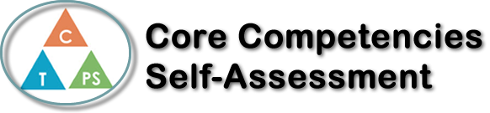
Name: | Date:

  How does the artifact you selected demonstrate strengths & growth in the communication competency?  In what ways might you further develop your communication competency? | Self-Reflection  Describe how the artifact you selected shows your strengths & growth in specific core competencies. The prompt questions on the left - or other self-assessment activities you may have done - may guide your reflection process.  The lab that I chose to show strengths & growth in the communication competency was the breakfast burrito lab. Why I chose this lab was because for this lab, we needed to be in partners of two. Personally, for me, I do not like having a partner because it is just going to be awkward, which I is why I prefer to work in groups. Fast forward into the making of the breakfast burritos, there was a bit of a communication barrier between me and my partner and eventually we had to start communicating since we were behind everyone. After we finished the lab, I realized that having a partner was not as bad as I thought it was going to be. So that really helped me be more open to having a partner. Another assignment that I chose was one of my quarantine cookbooks. Why I chose this assignment was because I remember this one time I was really struggling while writing down a recipe, because there was a problem of converting the measurements to imperial. So, for the first time I had to ask my teacher for help so I can find a solution, and out of luck, I did. Personally, I just never liked communicating with my teachers because I am very timid, but after this experience I finally realized that communicating to your teacher isn’t as bad as I thought it was going to be. So overall, I can say that my communication skills have improved, but with a bit more practice, then I’ll be confident communicating with teachers and students.


How does the artifact you selected demonstrate strengths & growth in the thinking competencies?

In what ways might you further develop your thinking competencies?


How does the artifact you selected demonstrate strengths & growth in the personal & social competencies?

In what ways might you further develop your personal & social competencies?

Publish Your Self Assessment
You will now attach and/or embed your self-assessment to the bottom of the blog post with the artifact you have chosen. You may choose to make this post private or public. After placing your artifact on a blog post, follow the instructions below.
- Categories - Self-Assessment
- Tags - Now tag your post using the tag that corresponds to the competency that you have written about. You can choose more than one. Please use lower case letters and be exact.
  - #creativethinkingcc
  - #communicationcc
  - #criticalthinkingcc
  - #socialresponsibilitycc
  - #personalidentitycc
  - #personalawarenesscc
- Use the Add Document button located at the top of your post page and embed your self-assessment at the bottom of your blog post.
- Publish

