New York Murders
Young gang member bled to death after witnesses did nothing to help

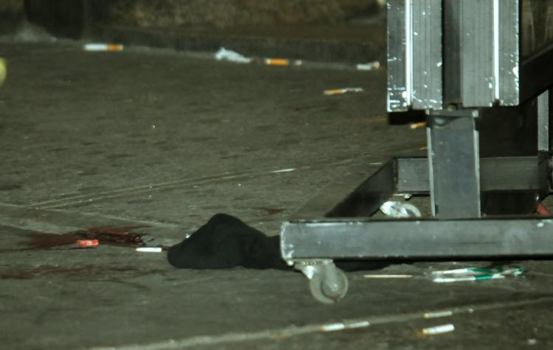
Source: Vic Nicastro from https://www.cbc.ca/news
Last night a “Royal” was found dead, by the NYPD and his girlfriend at 12:01 am on October 2, 2019.

Andy was a gang member who always cared about his girlfriend “Laura.”. However, Andy was stabbed at 11:30 pm in the Bronx, New York. It was reportedly said that Andy was walking through an alley when someone stabbed him under his rib cage making him bleed to death.

When interviewing his girlfriend “Laura,” she told us Andy was part of a gang that called themselves “The Royals.” Andy was fine with it, but she wasn’t.

The witness was a drunk middle-aged man. He stated “when I was stumbling by Andy, I saw a hole in the center of his jacket. I thought he tore his jacket when he fell he also said “if I wasn’t so drunk than I would’ve helped him and now I regret my decision of being drunk.”

Another witness was a man who walked through the alley with his partner. When they reportedly saw Andy on the ground making “Freddie” check Andy to see if he was fine. When Freddie had gone, he saw Andy was stabbed and asked him for help.

“I knew he was stabbed, but I couldn’t help him because, he was part of the Royals by his jacket. So, I left,” said Freddie.

Our final witness is a partially deaf elderly woman who hadn’t seen Andy but was stated to be a witness after she was spotted in the streets leaving the alley.

“There’s not that much evidence of who the criminal is but looking deeper into the investigation we’ll find this criminal,” said NYPD’s forensic scientist.

Published by Ahmed Amara

