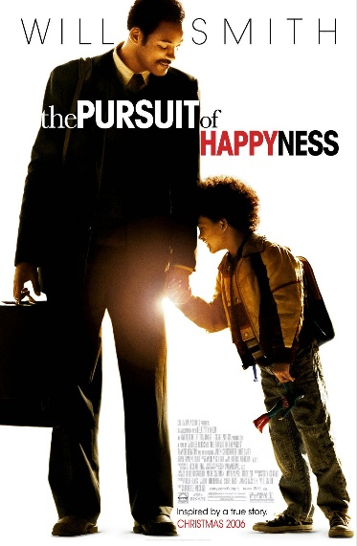
Synopsis: Chris Gardner is a salesman but the sales record is not good and it has brought his family in financial difficulties. His wife, Linda leaves and moves to New York. Chris is left to raise his 5 year-old son, Christopher on his own. Chris’ determination finally pays off when he lands an unpaid internship in a brutally competitive stockbroker-training program, where only one in twenty interns will make the cut. But without a salary, Chris and his son are evicted from their apartment and are forced to sleep on the streets, in homeless shelters and even behind the locked doors of a metro station bathroom. With self-confidence and the love and trust from his son, Chris Garden overcomes his obstacles to become a Wall Street legend.

- Job Interview scene

Chris is arrested for failure to pay parking tickets the night before his job interview and has to stay in the police office for a night. He is having the interview at 10:15 in the next morning and he leaves the police office at 9:35am. Let’s see how the interview goes.

- How does Chris go to the interview company?
___________________________________________________________________________

- What is Chris wearing to the interview?
___________________________________________________________________________
- What does Chris do when he first walks into the interview room?
___________________________________________________________________________

- How did Chris do in his high school? How many students were there in his class?
___________________________________________________________________________

- How does Jay describe Chris’s dressing?
___________________________________________________________________________

Job Interview: Discuss the following questions with your group.

- Did Chris make a good impression at the job interview? Why or why not?
- If you were Chris, would you accept the offer from the company when you knew it was unpaid and there was no a reasonable promise of a job? Why or why not?

- Basketball Scene

Chris brings Christopher to a basketball court to play basketball on a Saturday. Christopher tells Chris that he is going to be a professional basketball player. Watch the clip and listen to the conversations between the father and son.

- Where does Chris tell his son they will go after playing basketball?
___________________________________________________________________________
- How does Chris respond to his son when Christopher says he is going pro?
___________________________________________________________________________
- What does Christopher do to the basketball after hearing from his father?
___________________________________________________________________________
- What does Christopher use to hold his basketball?
___________________________________________________________________________

Basketball: Discuss the following questions with your group.

- At first, Chris told his son that he will never be a good basketball player. Then he gives his son different advice. What did he tell his son?
- Why does Chris change his mind and tell his son a different advice? Who do you think he is actually talking to?

- Football match scene
Chris has successfully reached a potential client and is offered a chance for an appointment. However, he misses it because his boss asks him to park the car for him. In order to get a second chance from the potential client, Chris takes his son with him to visit the client at weekend. Will Chris get his first client from this chance?

- When they are walking to Mr. Ribbon’s house, Christopher asks Chris if they are going to the football game. How does Chris reply to his son?
___________________________________________________________________________
- How does Christopher finally interpret the difference of the meaning between ‘probably’ and ‘possibly’ in term of the chance of going to the football game? ___________________________________________________________________________
- What does Chris say when Mr. Ribbon asks why Chris shows up in front of his door?
___________________________________________________________________________
- Where does Chris tell Mr. Ribbon they are sitting when he asks where their seats are?
___________________________________________________________________________
- What does actually ‘a box’ mean when referring to the seats in a football game?
___________________________________________________________________________

Football game: Discuss the following questions with your group.

- At the football game, the rich client told Chris that he will not use his services. However, this was actually a lucky day for Chris. Why?

- Subway scene
Chris’s money has been taken by the government for paying taxes. He is broke and they are evicted from the motel. Chris and his son are homeless and now they have nowhere to stay. How can Chris and his son face all these difficulties and go on their life?

- Where do Chris and his son go after they discover their things are thrown out of their motel room?
___________________________________________________________________________
- Chris tells Christopher that the guy in the park is correct and says the scanner is actually a ____________________________.
- After pressing the black button and opening their eyes, what does Chris tell Christopher that he can see?
___________________________________________________________________________
- Chris says to Christopher that they are cavemen and they have to find a cave in order to be safe. Where do they finally stay?
___________________________________________________________________________
Subway: Discuss the following questions with your group.

- Do you think it is alright for the government to take money directly from the bank account of those who are overdue to pay for the taxes without sending a prior notice? Why or why not?
- If you were Chris, what would you feel and would you continue to work in the company for an unpaid internship?

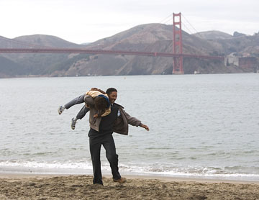
- Ending scene
Six months have passed and it is the last day of Chris’s internship. He is called to enter the conference room. Can Chris be the one who gets the official employment from the company after the internship?

- How does Chris’s boss respond to him when he says he wears a shirt for the last day of the internship?
___________________________________________________________________________
- What does his boss almost forget?
___________________________________________________________________________
- Where does Chris go after seeing his boss in the conference room?
___________________________________________________________________________

Ending: Discuss the following questions with your group.

- In your opinion, what was Chris’ worst experience?
- Chris has become successful and rich at the end. Do you think he has pursued happiness now? And to you, what does happiness mean to you and how do you pursue it?
- How would you describe the personalities of Chris?
- What is the message of the story?

