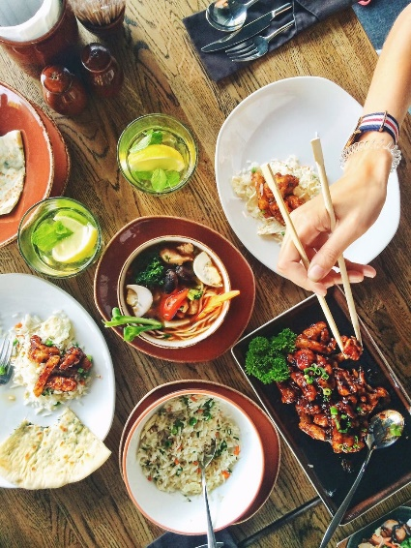
E A T
We need to eat to survive, but we also eat for enjoyment. Sharing a meal with others is a social activity that is a regular part of life. Make dinner for your family and take a picture at each stage. Then create a collage of the process with a reflection of how it went. You have one week from today to complete this assignment.

- Plan a dinner meal
What is on the menu?

- List the food
- What do you have already?
- What do you need to buy?

- Grocery shop

- Make dinner

- Share a meal together
Sit down with as many people in your family as you can and eat together. No phones at the table! Use this time to talk together.

- Clean it all up
Wash, dry and put away all the dishes that don’t go in the dishwasher
Sweep the kitchen floor and the under the table.

- Reflection
How was dinner?
Who did you serve?
Did it taste good?
What was the best part?
What was the worst part?
Did anything surprise you?

- Collage
Create a collage of the process leading up to dinner and your family eating dinner together. Post this collage and “add” your reflection to myblueprint in your “Life Skills” portfolio.

