Resistance – Connection between Voltage and Current
________________________ will flow if a ________________________ is applied to the circuit.
= electrons will move if they are ______________________________________________________.
The same voltage does NOT always produce the same current due to ________________________.
RESISTANCE - how ______________________ it is for electrons to flow through the material
- measured in a unit called ______________(Ω) by using an _____________________.

RESISTOR - any __________________ that decreases the flow of ______________________ in a circuit.
Ex. Any kind of ______________________
Ex. Compressed carbon resistors use ______________________________ to indicate the resistance that they provide.
Each colour has a given number value:
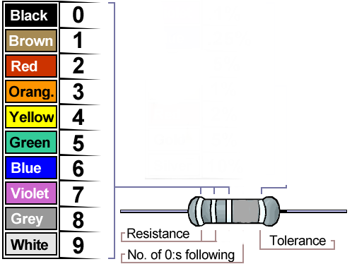
1st Band =
2nd Band =
3rd Band =
4th Band =
Gold = $±$ 5%
Silver = $±$ 10%
No band = $±$ 20%

Example: Red Black Red

Resistance Notes
Practice:
1. Blue Orange Red Silver
2. Yellow Yellow Orange Gold
3. Grey Green Yellow
OHM’S LAW-
A scientist named George Ohm conducted experiments with circuits and determined that there is a relationship between voltage, current and resistance.
His work lead to the creation of _________________________________.
OHM’S LAW | Symbols | Unit
PRACTICING OHM’S LAW
1. An electrical device with a resistance of 3.0 Ω will allow a current of 4.0 amps to flow through. What is the voltage across the device?

2. When a voltage of 120 V is used across an electric heater, a current of 10.0 amps will flow through the heater if the resistance is ______ Ω.

