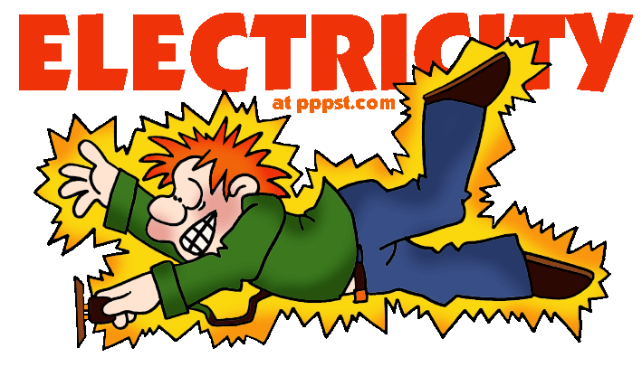
- Using your own words, define the word, “electricity.”

- List 10 devices that use electricity.

- Briefly describe what life would be like without electricity.

- Write three questions about electricity that you would like answered during the Electricity Unit.

