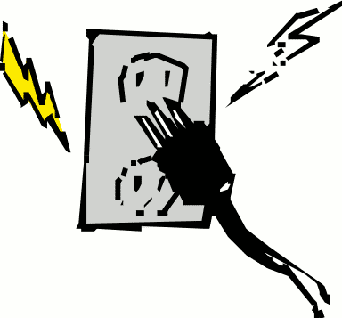
Current Electricity
- Static electricity forms when charges remain on an object for a while.
- Current electricity forms when ________________________________________.
- Current is formed when a device changes other forms of energy into electrical energy.

CURRENT ELECTRICITY:
- Results from the ___________________________of
- The movement has TWO components:
A. ________________________ - measured in Volts (v) – similar to water pressure
B. ________________________ - measured in Amperes (A) – similar to water flow
(how much water past a certain point in one second)
VOLTAGE (V):
- To make electrons move, they have to be pushed. They are forced along a metal in one direction.
- This push is called voltage or _____________ ___________________
- Measured in _____________ by a device called a ____________________.
- It can be described as a measure of the electrical pressure produced by battery or power supply.
We get electrical energy from a __________________ ___________.
Two or more chemical cells joined together is a ___________________.
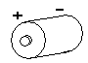

Cell (symbol in schematic diagrams)

BATTERIES:
Batteries produce a ___________________ by using _____________________________________ to produce a difference in electrical potential energy between the positive and negative terminals.
Electrons are pushed from the ________________________ terminal to the ___________________________ terminal.
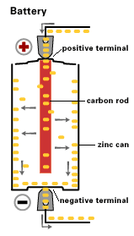
- The size of the ________________________ is called __________________________

- Electrons at the negative terminal are ___________________ and therefore have ____________________________ (pressure) and want to get away from each other.

Batteries can be connected in TWO ways:
1) Series: ____________________________________________________________.
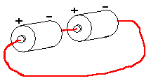
Schematic Diagram:

2) Parallel: _________________________________________________________.
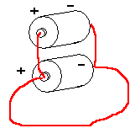
Schematic Diagram:

SHORT CIRCUIT:
If a circuit is interrupted allowing a current to travel down an path, it causes too much in a wire. That is called a .
The excessive current can either cause the power source (like a ) to heat up, “short” and be destroyed; or a (if it is doing its job) to blow, breaking the flow of current in the circuit.
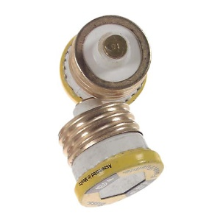
At home, a short circuit can be and to your appliances and electronic devices. The most common cause of a short circuit in the home is touching when they shouldn’t.
