Spheres Quiz REVIEW
Your quiz next day will be out of 15 marks. It will include multiple choice questions and 1 short answer question.
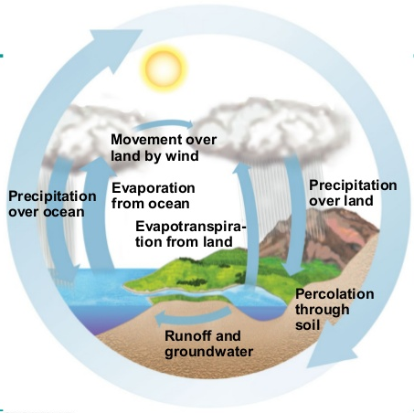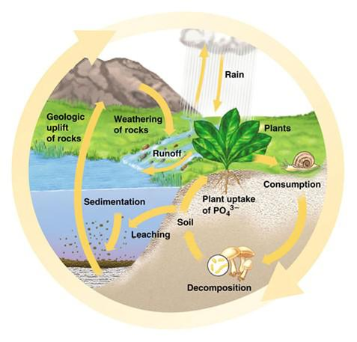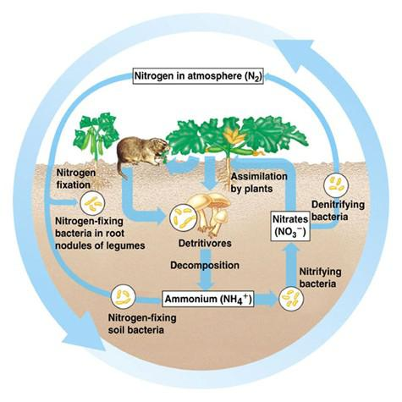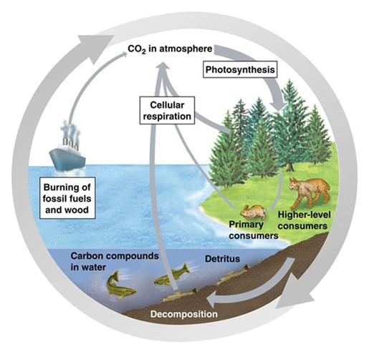
- If a bird eats an insect that ate a plant, what would the bird be considered?
2. Between producer and secondary consumer, about how much energy is lost?
3. What type of organism must be at the beginning of every food chain?
4. When an organism dies, what happens to its matter?
5. How do plants contribute to the carbon cycle?
6. What converts nitrates and nitrites into nitrogen gas?
7. What would happen without decomposers and detritus feeders in an ecosystem?
8. Give one example each of how humans affect the following.
(a) carbon cycle
(b) nitrogen cycle
(c) phosphorus cycle
9. What is the Scientific Method?
10. What role does respiration and photosynthesis play in the carbon cycle?
11. What is a decomposer, producer, primary consumer and top carnivore? Give an example of
each.
12. What is the difference between biotic and abiotic?
13. How is nitrogen removed from the atmosphere?
14. What are several effects of global warming on our planet?
15. What is a trophic level?
16. Explain how you can personally reduce your ecological footprint.
17. Why does a global temperature increase cause the sea level to rise?
18. What is a watershed?
19. When testing for water quality, what is being tested and what do the tests mean?

