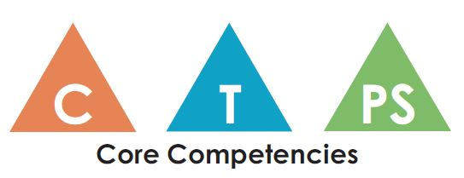
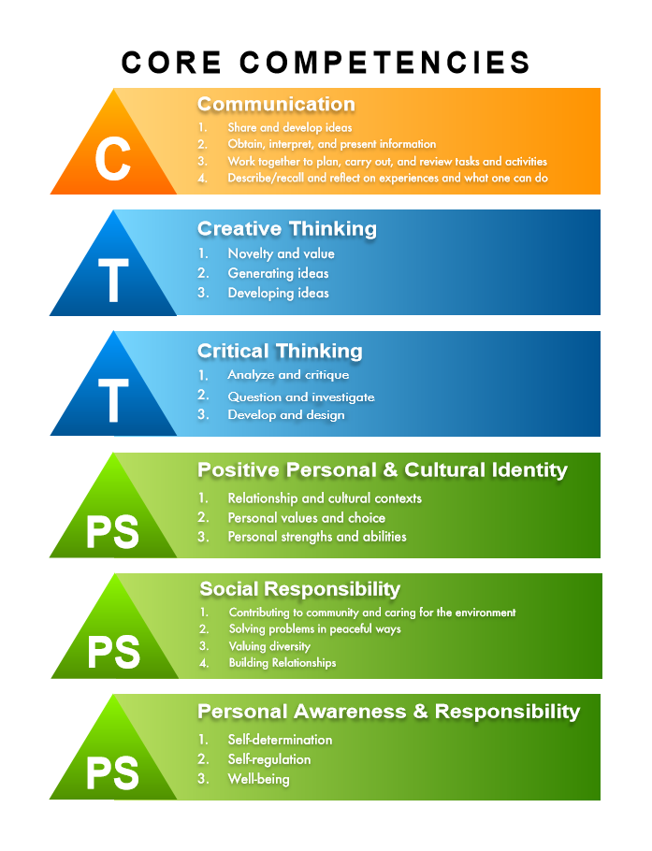
Communication
- How do you show that you are listening thoughtfully?
- What listening skills do you use to enhance your learning?
- What are some ways that you use to communicate your learning?
- What do you do when you disagree with someone in your group or discussion? How did you learn/develop that strategy?

Social Responsibility
- How do you use words and actions to encourage other students who might be feeling a bit sad or discouraged?
- What contribution have you made to our school that you feel good about? How did you get started doing that?
Positive and Personal Cultural Identity
- What are your strengths as a learner and how do you learn best?
- What are some aspects that you value about your culture?
- How do you portray aspects of your cultural contexts in your work? (e.g. through images or words)
- What are some things about your culture that you would like other people to know?
- How do you use your strengths and abilities in your family, relationships, and community?
Personal Awareness and Responsibility
- Tell me about one of your learning goals. (Prompt: Something you want to get better at or learn how to do.) How did you come to that goal? Tell me about something you are doing to help you work on that goal?
- What do you do to help yourself when you are feeling a bit discouraged about your work?
- Think of times when you have to wait. What strategies do you use when you are feeling impatient? How did you develop that strategy? When did you start? How does it work?

