SCIENCE 9 Name:
Energy Flow in Ecosystems Date:

All organisms in an ecosystem interact with their ecosystem by

We can model the flow of energy in an ecosystem using food chains and food webs.
- Food chains show the flow of energy from plant to animal and animal to animal. Each step in the food chain is called a .
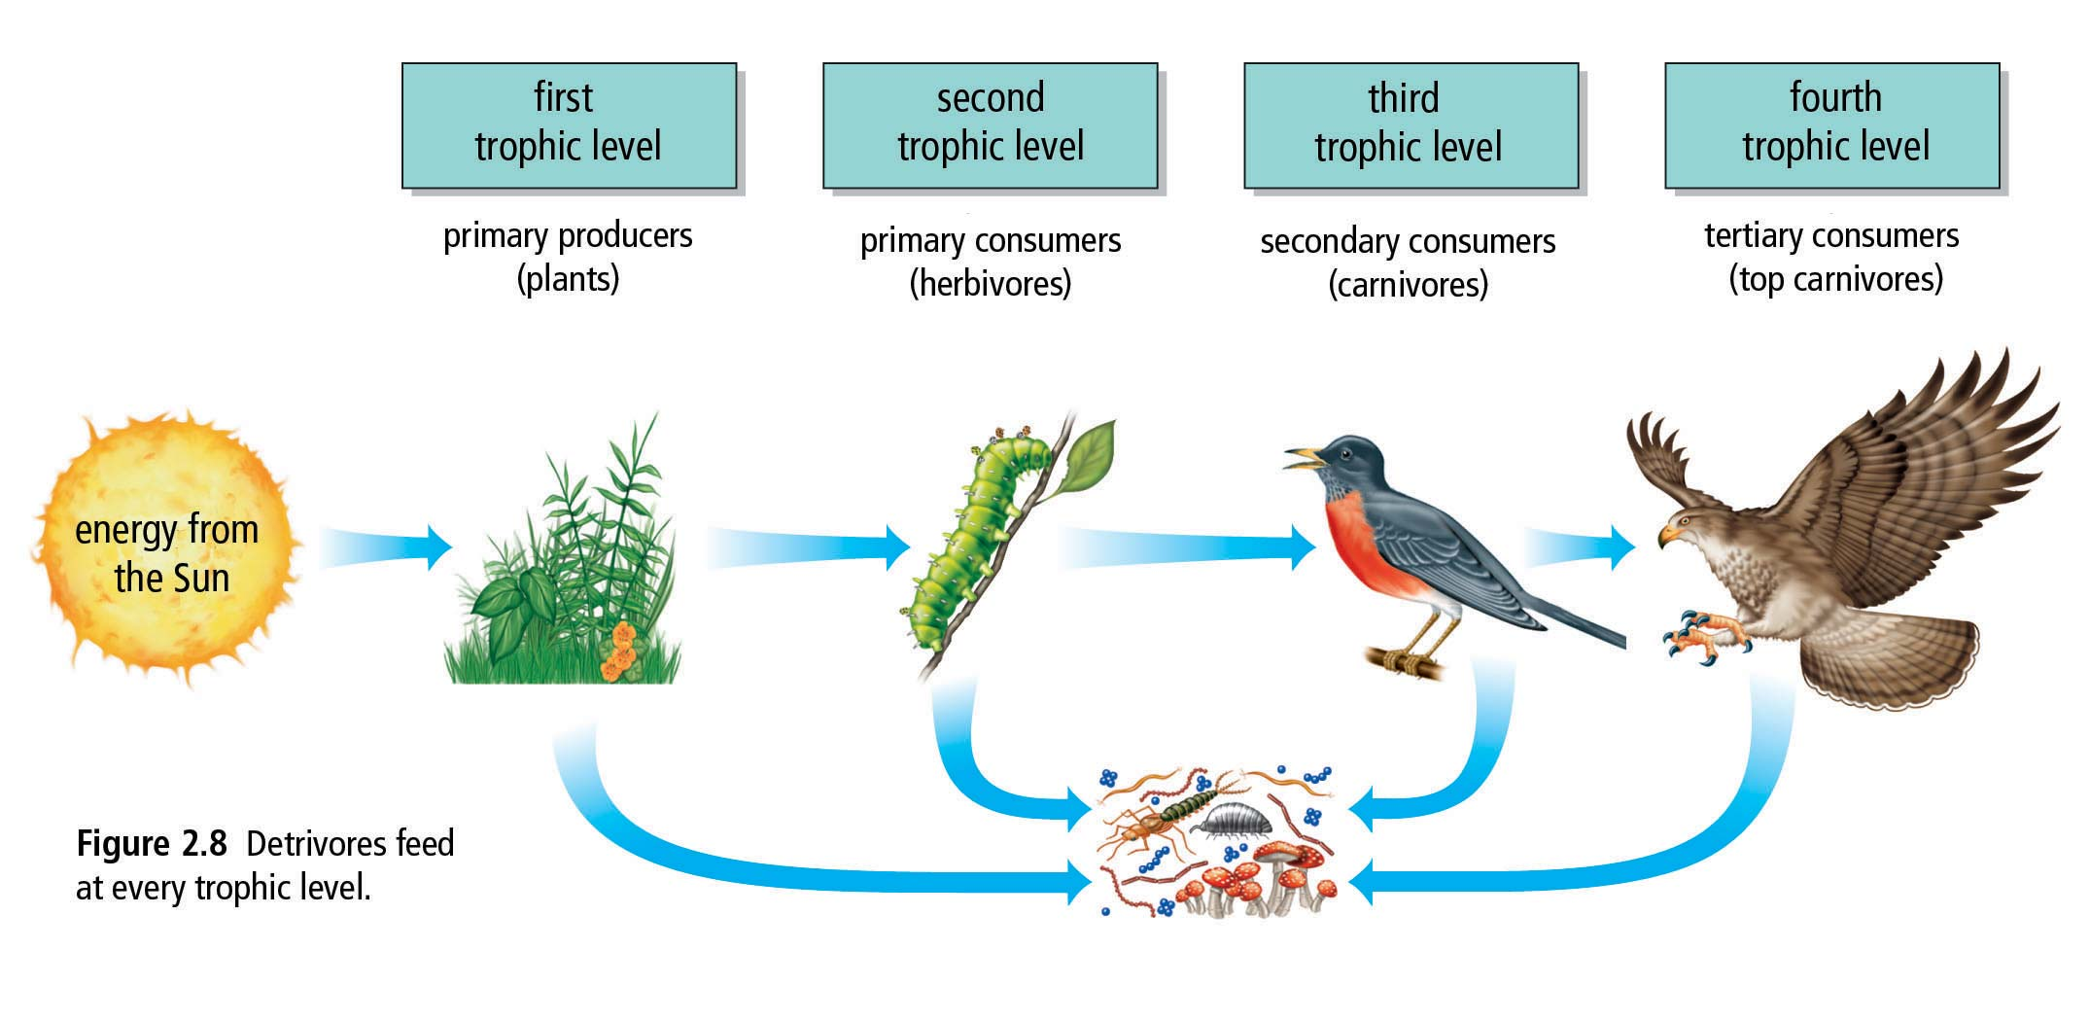

- Food webs demonstrate the feeding relationships within an ecosystem.
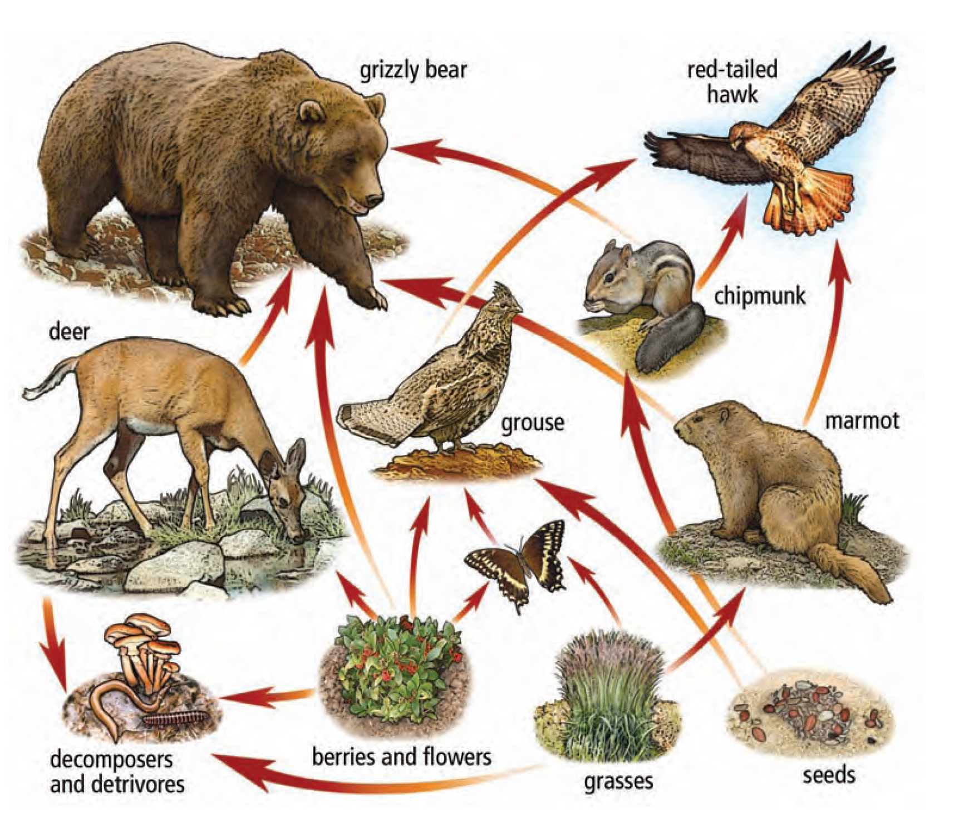
Discuss the following from the food web above:
- Name 2 organisms in the first trophic level

- Name 1 herbivore, 1 omnivore, and 1 carnivore

- Name 1 organism in the second trophic level.

- Name 1 secondary consumer

- Name 1 organism that occupies both the second and third trophic level.

- What would happen if all the decomposers and detrivores disappeared from this food web?

- What would happen if there were no plants in this food web?

- If a pesticide, such as DDT, were introduced to this food web, which organisms do you think would be most affected?

- Explain why plants are called primary producers.

- (a) Are herbivores primary consumers? Explain why or why not.

(b) Are carnivores primary consumers? Explain why or why not.

(c) What is an omnivore?

- How much energy is lost from producers to secondary consumers?

- What is the main difference between food chains and food webs?

Energy Flow Follow-Up

- Try the following Antarctic food web game:
http://d3tt741pwxqwm0.cloudfront.net/WGBH/conv16/conv16-int-oceanfoodweb/index.html
  - Read through “Food Chains/Webs” and “Trophic Table” then try the “Food Web Game.” Paste screen shot of your completed food web below.

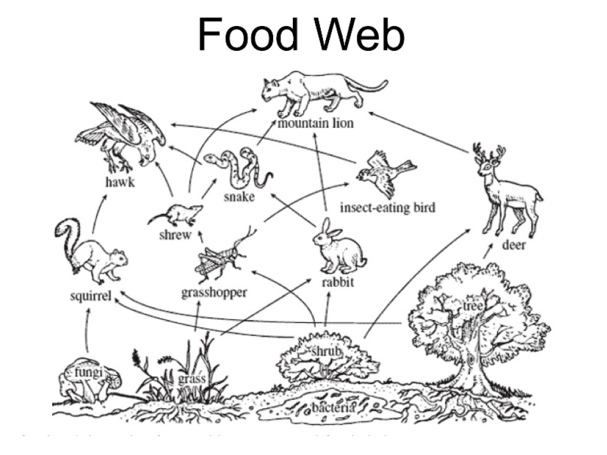
- Use the following food web to answer the following questions:
- Name 2 organisms in the first trophic level.

- Name 2 primary consumers.

- Name 2 secondary consumers.

- Name 2 herbivore and 2 carnivores.

3. If there are 1 000 000 kcal/m2 in the producer level of a food pyramid, how many kilocalories will be
incorporated into the bodies of the following, if there is a 90 percent energy loss at each level?

(a) primary consumers
(b) secondary consumers
(c) tertiary consumers

4. Explain why you do not gain weight every time you eat.

5. What would be the impact on life on Earth if less and less solar energy were able to reach Earth’s surface?

