Name:
Block:

Safety Scavenger Hunt

Find a student in the class that can demonstrate or answer the following questions. You must find a different person for each question. Write your answer in the space provided.

Question / Answer | Student Name
- How do you find the odor of a substance?
Answer:
- If a chemical is spilled, what should you do?
Answer:
- If you see someone rubbing their eyes after getting chemicals in their eyes, you should…
Answer:
- The minimum amount of time needed to wash your eyes after contact with harmful chemicals is …
Answer:
- Which 2 of your 5 senses should not be used in the lab?
Answer:
- You see someone with their long hair getting close to soaking in some chemicals, you should …
Answer:
- Some acid comes in contact with your hands. What should you do?
Answer:
- You see someone’s sleeve catch fire. Describe what would you do?
Answer:
- Someone owns contact lenses and glasses. Which is better to wear during an experiment and why?
Answer:
- What does WHMIS stand for?
Answer:
- What is the meaning of each of the following chemical symbols?
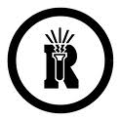Answer:
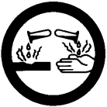 Answer:
Answer:
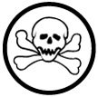 Answer:

