Science App Review

Questions:
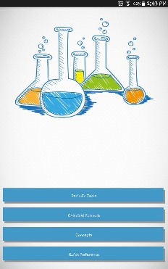
1. What part of science does this app teach?
2. Is it any difficult to use?
3. What platform is it available on?
4. Does it have a lot of features?
5. Can users learn a lot?
6. How much storage space will it need to download?

This app is called “Complete Chemistry app”. It is only available for android devices. It teaches various things from chemistry. Such as the periodic table, some concepts, chemistry formulas, and references. It takes up 8.41MG of memory.

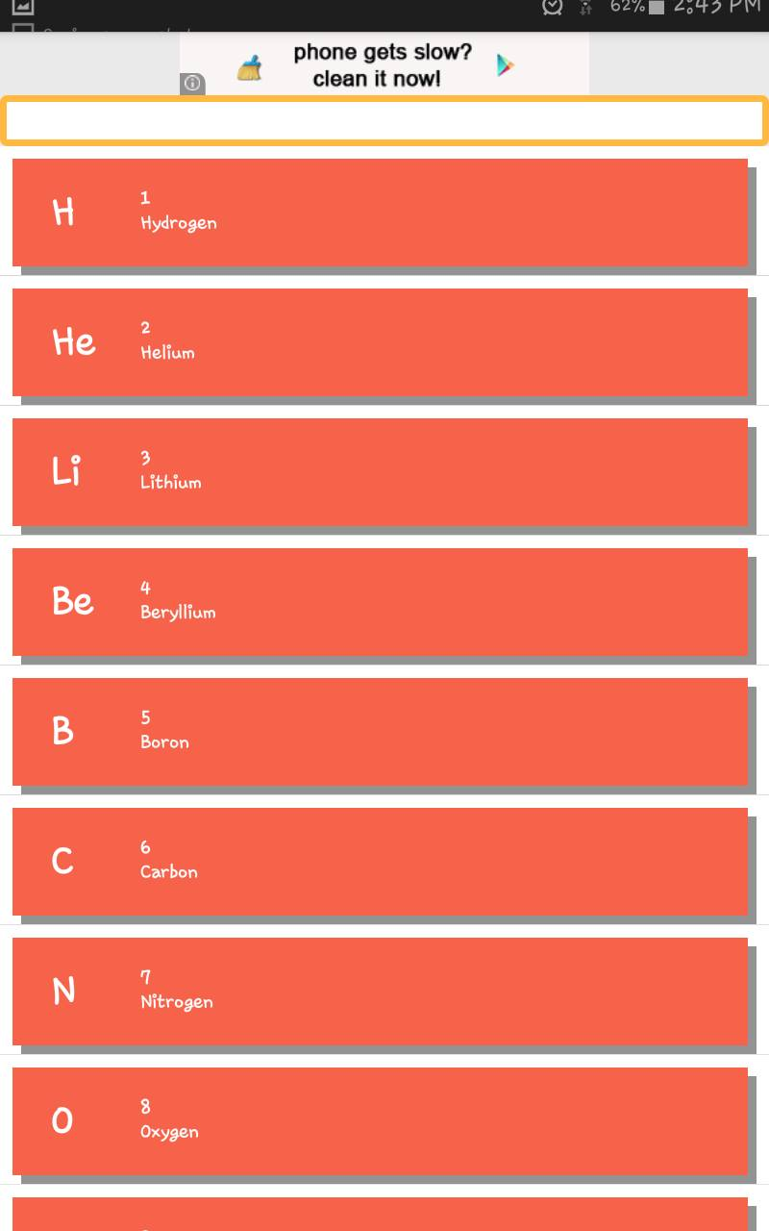
When you press “Periodic Table” it brings you to something that looks like the picture on the right. It brings you to a page full of all the elements in the periodic table. To me the only downside is that it doesn’t actually show a table!
Also when you press an element it shows you the following.

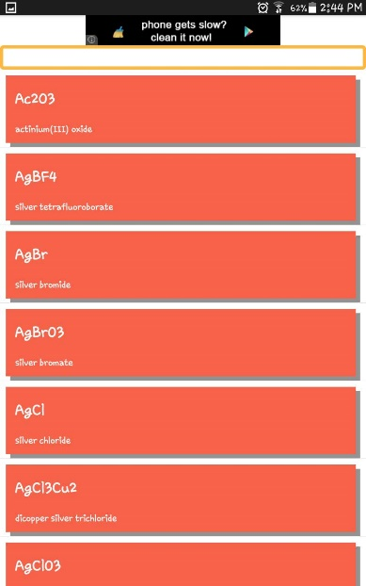
This app also features Chemical formulas! As you can see it has all these formula and it has more! It’s like a dictionary for all the chemical formulas, which can be very helpful when you do homework or in class assignments!

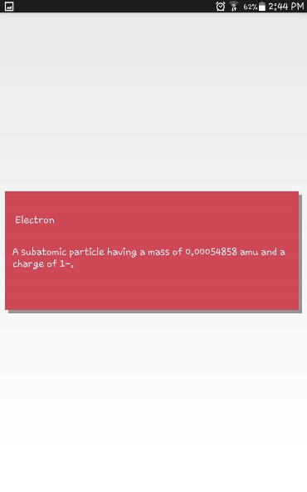
Another thing you can do with this app is the concepts! It is basically all the vocabulary words in chemistry. Again it can be helpful when doing work.
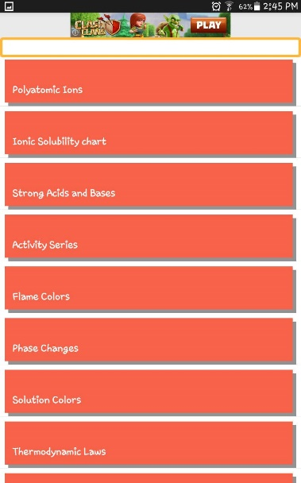
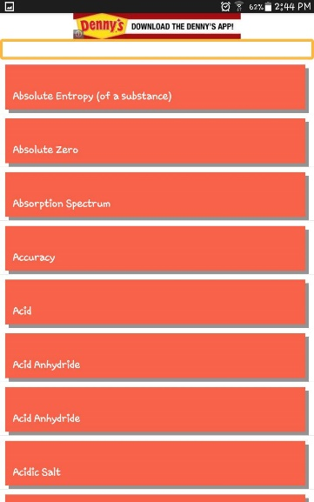 The last feature of this app is the Quick References. It has all the basic things in chemistry.

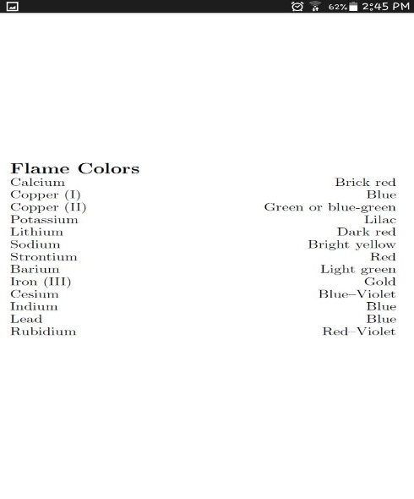
I pressed on the Flame colour one and
this will appear

