
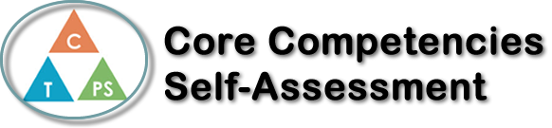
Name: Aaron Chiu | Date: Nov. 6th, 2023

  How does the artifact you selected demonstrate strengths & growth in the communication competency?  In what ways might you further develop your communication competency? | Self-Reflection  Describe how the artifact you selected shows your strengths & growth in specific core competencies. The prompt questions on the left - or other self-assessment activities you may have done - may guide your reflection process.  During my narrative essay I used critical thinking to analyze my own beliefs through reflecting on my past. I considered decreasing my ego and studying more every day to be more successful on future assignments. I tried using study guides and techniques such as studying a little every day, playing less video games every day to study and reviewing the next day’s lesson if possible. This was successful as I understood the material taught better, letting me be more successful in school. As a goal I would like to improve on managing my time more effectively and efficiently allowing me to study more in a short amount of time.


How does the artifact you selected demonstrate strengths & growth in the thinking competencies?

In what ways might you further develop your thinking competencies?


How does the artifact you selected demonstrate strengths & growth in the personal & social competencies?

In what ways might you further develop your personal & social competencies?

Publish Your Self Assessment
You will now attach and/or embed your self-assessment to the bottom of the blog post with the artifact you have chosen. You may choose to make this post private or public. After placing your artifact on a blog post, follow the instructions below.
- Categories - Self-Assessment
- Tags - Now tag your post using the tag that corresponds to the competency that you have written about. You can choose more than one. Please use lower case letters and be exact.
  - #creativethinkingcc
  - #communicationcc
  - #criticalthinkingcc
  - #socialresponsibilitycc
  - #personalidentitycc
  - #personalawarenesscc
- Use the Add Document button located at the top of your post page and embed your self-assessment at the bottom of your blog post.
- Publish

