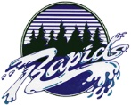
Name: Aamenah Hassan | Date: January 14, 2020

X  How does the artifact you selected demonstrate strengths & growth in the communication competency?  In what ways might you further develop your communication competency? | Self-Reflection  During this semester, I believe the adaptive tech CBL project helped me develop my communication skills the most. I was constantly doing my best to make sure everyone was on the same page despite having a small language barrier with one of my group mates. The language was not a problem, it just meant that my other group mate and I would sometimes have to try and explain or restate what we said using different words, which helps further communication skills and helps make sure we know the meaning behind what we say. I have always had a lot of trouble explaining myself, but I slowly found myself being able to verbally express my thoughts as time went on, at least to a decent extent.  I think I could have tried a bit harder at verifying that we all understood what was going on. Even if I tried my best, I do not know if what I had done was enough. The main reason for that was that any time I had asked if she understood, heard or had something to say, she spoke so quietly I could never hear her. Looking back on it, I probably could have asked her to type out what she wanted to say after trying to hear her instead of asking her to repeat it three or four times only to have minimal understanding of what she said.
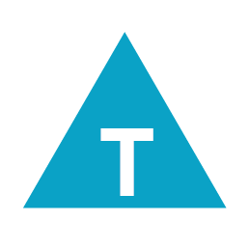

How does the artifact you selected demonstrate strengths & growth in the thinking competencies?

In what ways might you further develop your thinking competencies?

How does the artifact you selected demonstrate strengths & growth in the personal & social competencies?

In what ways might you further develop your personal & social competencies?

