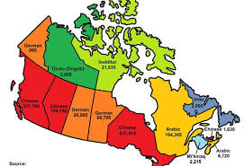
I chose this picture because this is the map of Canada.
Canada has 34 ethnic groups, each with at least 100,000 people, 11 of whom have more than 1 million, and many others less.
Canada, one of the northernmost countries in North America, is known as the "land of maples" and the capital is Ottawa.
Canada west to the Pacific Ocean, east to the Atlantic, north to the arctic ocean, the south to the United States borders, the northwest and the United States Alaska neighbors. The territory is the second largest in the world with an area of 998,467 square kilometers, most of which lies within the Arctic Circle. The official languages are English and French, typical bilingual countries.

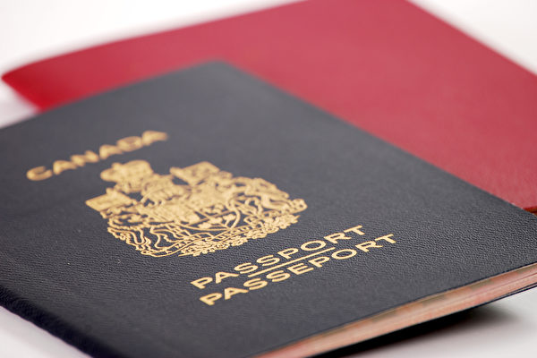
The reason I chose this photo is that this is a Canadian passport, if you have it you are a Canadian.

