**SMART GOAL: Personal**

(Specific, Measurable, Achievable, Realistic, Timely)

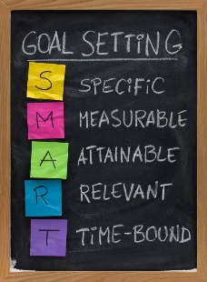 **GOAL STATEMENT:**

My goal is to pass all my courses by putting in as much effort as I can by asking for help when needed and taking help when offered

**WHAT DO I NEED TO REACH THIS GOAL? (The steps you**

**must take in order, and the date you wish the step to be**

**completed by.)**

I wish to complete this goal by June

**HOW ARE YOU GOING TO MEASURE THE PROGRESS TOWARDS**

**YOUR GOAL?**

I will measure my progress by asking my teachers what my grades are throughout the semester

**OBSTACLES YOU MIGHT SOLUTIONS**

**FACE**

Some solutions to the obstacles are

Prepare for any upcoming Assignments

Some obstacles I might come across are

Test

Assignments

Major projects

Procrastination

**WHO ARE YOU GOING TO SHARE YOUR GOAL WITH?**

My Grandma my Dad and my Mom

**HOW WILL YOU CELEBRATE YOUR GOAL?**

I will probably get a steam card

**NEVER GIVE UP!**