Float Your Boat Challenge
By: (First & Last Name)
Group Members:
Science 10 Block __

Problem:

Hypothesis: Use an “If… (independent variable) then… (dependent variable) because” statement.

Observations:
Insert 3 pictures of the boat design and label them
- Top view
- Bottom view
- Picture during the challenge

Results and Conclusions:
The boat held…
19
The original thinking and reasoning behind the design was…
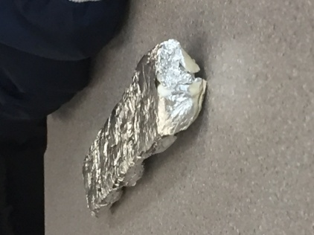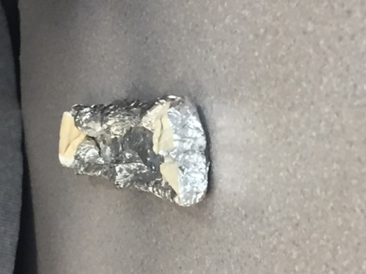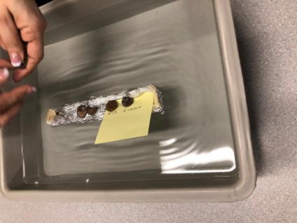
Bottom top in water
If the following challenge was repeated, to improve the boat design, the following changes would be made….because….
I would make it higher so it would take longer to go down and put I would put more buoyancy on the edges

Upload this document to your Edublog and Tag your post “floatyourboatdurandsc10blk_” add your block letter “C or D”

