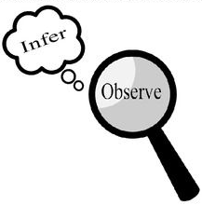
Observations and Inferences
Science 10 Name: Zack BLK: B

OBJECT | OBSERVATIONS  Words that describe the object | INFERENCES  Ie: Where might the object come from? Possible uses? Etc. | QUESTIONS YOU HAVE ABOUT THE OBJECT
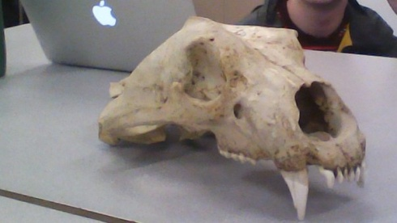 | Badge spots of brown | Wild life research
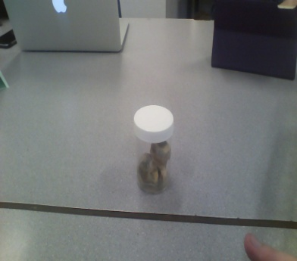
Research for humans eyes
a cow or sheep
Looks well preserved
Was it alive? How old is it?
Brown and grey in the middle

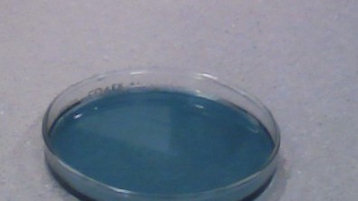 | Blue | Seems like its laundry detergent | What is the scent?
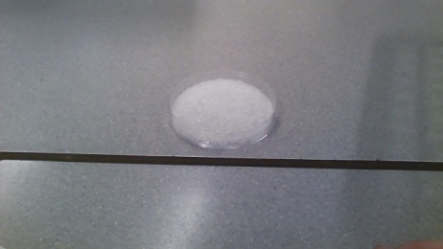 | White | A salt or sugar | Was it a powder? Where did it come from?

Observations/Inferences Assignment Assessment
Name: _____________________
Ex: Excellent VG: Very Good G: Good S: Satisfactory IN: Improvement is needed
Criteria | IN | S | G | VG | Ex
The following is included
- All 4 Images included
Observations:
- A minimum of 5 detailed observations made
Inferences:
- Thoughtful and logical inferences made
Questions:
- 2 thoughtful and logical questions made
- Spelling/grammar
- Assignment was completed on time
/10

