SMART GOAL: Personal
(Specific, Measurable, Achievable, Realistic, Timely)

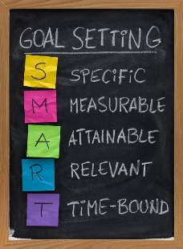
GOAL STATEMENT:
I want my English skills to progress enough to take English class.

WHAT DO I NEED TO REACH THIS GOAL? (The steps you
must take in order, and the date you wish the step to be
completed by.)

I will study English for five hours after I came back home from school. I will memorize 50 words. I am going to try participating classes that I take in this semester. Also, I will try making new friends or speaking in English with my friends including people who are from South Korea either. I will never visit internet except to search for information until I finish all works.

HOW ARE YOU GOING TO MEASURE THE PROGRESS TOWARDS
YOUR GOAL?
Depending on the marks or comments of my EAL teachers on the report card, I will check, refer, and fix my ways to study.

OBSTACLES YOU MIGHT SOLUTIONS
FACE
I could decrease time to sleep, eat, or talk about useless subjects.
It might be really hard to me to make new friend who can speak in only English to me.
Also, I might not be able to finish my works of English studies for another works which are too much to end in a day or my laziness.

WHO ARE YOU GOING TO SHARE YOUR GOAL WITH?
It is with my friends who are international students. In my opinion, they could agree and emphasize my goal easier. Also, it could be my parents because they always trust and support me.

HOW WILL YOU CELEBRATE YOUR GOAL?
I could make that my parents would be happy for succeeding to reach my goal, so I do not need more celebration.

NEVER GIVE UP!

