I learned slope and equation of a line this week.
The shape of equation is
y=mx+b

In Japan we learn this type of equation like
y=ax+b

This was a small difference but it makes confusing.

In this case “a” is Rate of change of graph
change of y

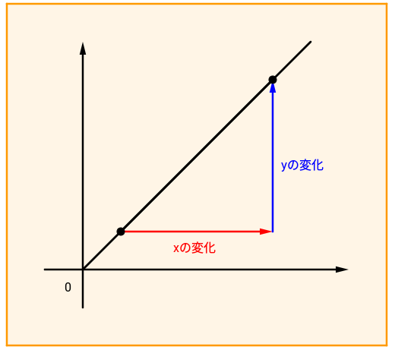 change of x

“a” is going to be change of y /change of x

I had to solve this type of problem in Japan.

Question. choose the linear function below

A y = -5x -2 B y = 3x² C y= x2 D y = 3x E 12x+2y-4=0

Linear function has to be linear equation

So answer is A C E

