1.MICROWAVE HAM, MUSHROOM & SWISS COFFEE CUP SCRAMBLE
Link: https://www.incredibleegg.org/recipe/microwave-ham-mushroom-swiss-coffee-cup-scramble/
INGREDIENTS:1EGG,25Oml water, 200g chopped mushrooms, 1 thin slice deli ham, chopped (1 oz.), 200ml shredded Swiss cheese.
Step1: COAT 12-oz. microwave-safe coffee mug with cooking spray. ADD egg, water, mushrooms and ham; BEAT until blended. MICROWAVE on HIGH 30 seconds; stir. MICROWAVE until egg is almost set, 30 to 45 seconds longer.
Step: SEASON with salt and pepper, if desired. TOP with cheese. SERVE immediately.
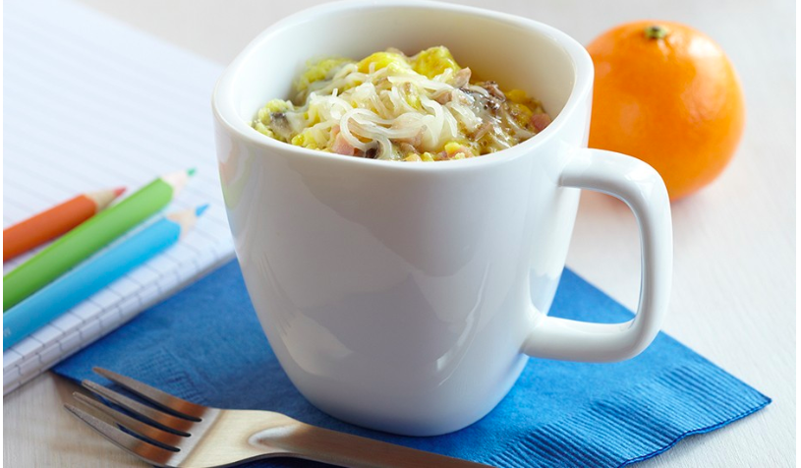

2. MICROWAVE EGG, SAUSAGE & TOMATO BREAKFAST BOWL
Link: https://www.incredibleegg.org/recipe/microwave-egg-sausage-tomato-breakfast-bowl/
INGREDIENTS: 2EGGS,250ml. milk, 200ml fully-cooked breakfast sausage crumbles, 100ml finely shredded Cheddar cheese, 200ml chopped tomato and 2 basil leaves, thinly sliced
Step1: COAT 2-cup microwave-safe cereal bowl with cooking spray. ADD eggs and milk; BEAT until blended. ADD sausage.
Step2: MICROWAVE on HIGH 45 seconds; push cooked edges toward center. MICROWAVE until egg is almost set, about 45 to 60 seconds longer.
Step3: TOP with cheese, tomato and basil. SERVE immediately.
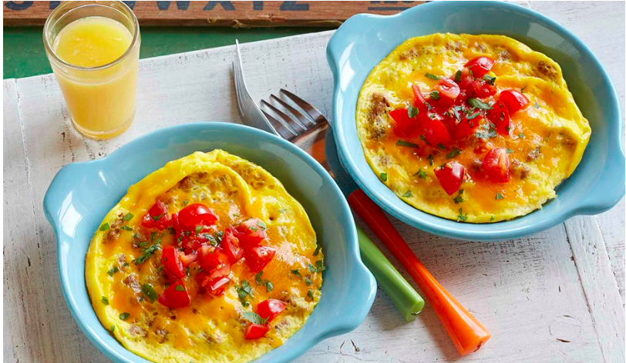

3. The sun egg
From Chinese website
INGREDIENTS: some eggs, carrots, potatoes, green onion, 400ml flour
Step 1: potatoes, carrot shears.
Step 2: prepare the right amount of flour, salt, scallions, eggs, and potatoes and carrots.
Part 3: brush a little oil in a pan to make a bird's nest.
Step 4: finally break the egg into the nest and fry until well done.
