The Battle of Vimy Ridge was part of the [Battle of Arras](https://translate.googleusercontent.com/translate_c?anno=2&depth=1&hl=ko&rurl=translate.google.ca&sl=en&sp=nmt4&tl=ko&u=https://en.wikipedia.org/wiki/Battle_of_Arras_(1917)&xid=25657,15700021,15700124,15700149,15700168,15700186,15700201&usg=ALkJrhheQsTlK6Q8l6uyUWbtnWY0Asmysw) , in the [Nord-Pas-de-Calais](https://translate.googleusercontent.com/translate_c?anno=2&depth=1&hl=ko&rurl=translate.google.ca&sl=en&sp=nmt4&tl=ko&u=https://en.wikipedia.org/wiki/Nord-Pas-de-Calais&xid=25657,15700021,15700124,15700149,15700168,15700186,15700201&usg=ALkJrhh9imjktSoSmLwzeVinlF_S5Ca3ng) region of [France](https://translate.googleusercontent.com/translate_c?anno=2&depth=1&hl=ko&rurl=translate.google.ca&sl=en&sp=nmt4&tl=ko&u=https://en.wikipedia.org/wiki/France&xid=25657,15700021,15700124,15700149,15700168,15700186,15700201&usg=ALkJrhhxvmFOmtPs82szb5xMkVECHz5RkQ) , during the [First World War](https://translate.googleusercontent.com/translate_c?anno=2&depth=1&hl=ko&rurl=translate.google.ca&sl=en&sp=nmt4&tl=ko&u=https://en.wikipedia.org/wiki/First_World_War&xid=25657,15700021,15700124,15700149,15700168,15700186,15700201&usg=ALkJrhj1bh70Dmp0Axn5anuryKwtc0zZ0g) . The main combatants were the four divisions of the [Canadian Corps](https://translate.googleusercontent.com/translate_c?anno=2&depth=1&hl=ko&rurl=translate.google.ca&sl=en&sp=nmt4&tl=ko&u=https://en.wikipedia.org/wiki/Canadian_Corps&xid=25657,15700021,15700124,15700149,15700168,15700186,15700201&usg=ALkJrhhjRU_U6_L-qcWfbsH-N6zk4qEgNQ) in the [First Army](https://translate.googleusercontent.com/translate_c?anno=2&depth=1&hl=ko&rurl=translate.google.ca&sl=en&sp=nmt4&tl=ko&u=https://en.wikipedia.org/wiki/First_Army_(United_Kingdom)&xid=25657,15700021,15700124,15700149,15700168,15700186,15700201&usg=ALkJrhj_XONny3GUQdgWBXzFeJSMBeO2ag) , against three divisions of the German [6th Army](https://translate.googleusercontent.com/translate_c?anno=2&depth=1&hl=ko&rurl=translate.google.ca&sl=en&sp=nmt4&tl=ko&u=https://en.wikipedia.org/wiki/6th_Army_(German_Empire)&xid=25657,15700021,15700124,15700149,15700168,15700186,15700201&usg=ALkJrhjxni7BIB_za78yJ_FIK1ulOqdGng) . The battle took place from 9 to 12 April 1917 at the beginning of the Battle of Arras, the first attack of the [Nivelle Offensive](https://translate.googleusercontent.com/translate_c?anno=2&depth=1&hl=ko&rurl=translate.google.ca&sl=en&sp=nmt4&tl=ko&u=https://en.wikipedia.org/wiki/Nivelle_Offensive&xid=25657,15700021,15700124,15700149,15700168,15700186,15700201&usg=ALkJrhhLXUc0gPZg6tRSCVGgB9phop0aog) , which was intended to attract German reserves from the French, before their attempt at a decisive offensive on the Aisne and the [Chemin des Dames](https://translate.googleusercontent.com/translate_c?anno=2&depth=1&hl=ko&rurl=translate.google.ca&sl=en&sp=nmt4&tl=ko&u=https://en.wikipedia.org/wiki/Chemin_des_Dames&xid=25657,15700021,15700124,15700149,15700168,15700186,15700201&usg=ALkJrhhHW_fMMbyb7Vbd0u5ZoloqVPZBig)ridge further south.

William Shatner / Battle of Vimy Ridge – You Tube

<Battle Of Vimy Ridge>

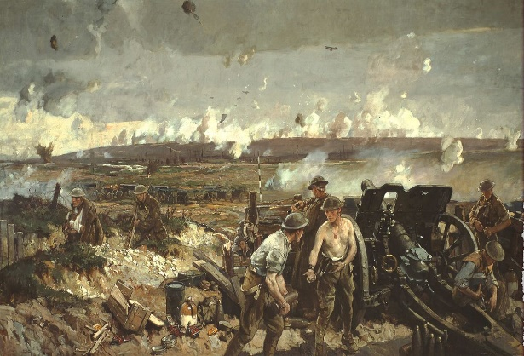

Date : 9 to 12 April 1917

Memorable aspects : The battle was the first occasion when all four divisions of the [Canadian Expeditionary Force](https://translate.googleusercontent.com/translate_c?anno=2&depth=1&hl=ko&rurl=translate.google.ca&sl=en&sp=nmt4&tl=ko&u=https://en.wikipedia.org/wiki/Canadian_Expeditionary_Force&xid=25657,15700021,15700124,15700149,15700168,15700186,15700201&usg=ALkJrhj6hZPtrb0KZbFQGov0CYvw2Ffcpw) fought together and it was made a symbol of Canadian national achievement and sacrifice.

Number of casualties : 3598 dead, 7004 wounded



The Battle of Vimy Ridge – You Tube



Lesson : War takes away the precious things of many people, such as family, property, and it should not happen again.