<Atomic bombings of Hiroshima and Nagasaki>

|  |  |
| --- | --- |
| **Information** |  |
|  |  |

**Date** : August 6 and August 9, 1945

**Location** : Hiroshima and Nagasaki , Empire of Japan

**Casualties and losses** :

Hiroshima:

* 20,000 soldiers killed
* 70,000–126,000 civilians killed

Nagasaki:

* 39,000–80,000 killed

**Total: 129,000–226,000+ killed**

**Result** : Allied victory

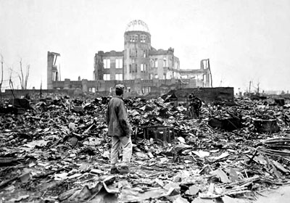

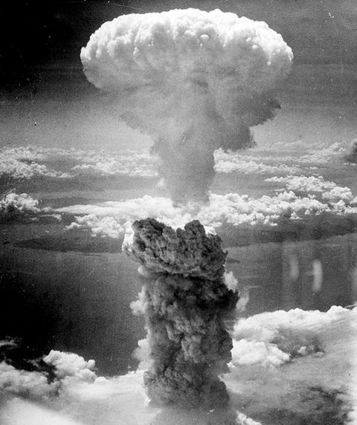

During the final stage of World War 2, the united states detonated two nuclear weapons over the Japanese cities of Hiroshima and Nagasaki on August 6 and 9, 1945, respectively. The United States dropped the bombs after obtaining the consent of the United Kingdom, as required by the Quebec agreement. The two bombings killed at least 129,000 people, most of whom were civilians. They remain the only use of nuclear weapons in the history of warfare.

Real Footage – Atomic Bomb– Hiroshima and Nagasaki – You Tube





Hiroshima: Dropping the Bomb – You Tube