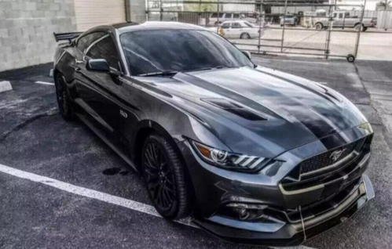
Willis future lifestyle
That’s car I want to buy,Because Mustang car look handsome , and the engine sounds good.
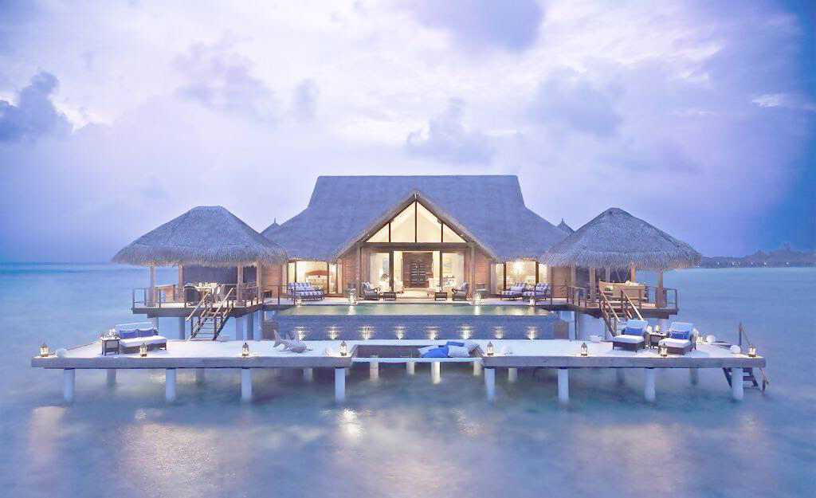
I love sea-view room because when I get up and withdraw curtain I can see the endless sea .that feel me relax.

I will go travel with my family in my spare time,Because scenery

When I’m 25,I will have a big house near the sea.and have a family.we will travel around the word in my spare time. I have a steady job and medium income.I want a flat life,Because there’s no much pressure.

