Vocabulary Words related to Judaism

Bar mitzvah – a Jewish ritual that marks the passage of a boy (13 years old) into the age where they can be held accountable for their own actions under the law (Torah). Before this age, the parents are held accountable for the child’s education.

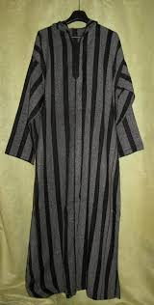
Torah – has a range of meanings. Could refer to Jewish law, or written pieces.

Kaftans – a type of garment worn by Jewish people; a tunic of the sorts.

Shabbat Eve – The day before Shabbat, which is the day of rest. According to customs, it is a day to remember the creation of heaven and earth in six days.

Phylacteries a small leather box containing Hebrew texts worn by Jewish men at morning prayer as a reminder to keep the law.

Rabbi – a teacher of the Torah (Jewish law)

Yom kippur – the day of atonement and repentance. In Juadaism, it is the holiest day of the year.
Figure 1 A kaftan

