Solar Cookers
Parabolic Boiler
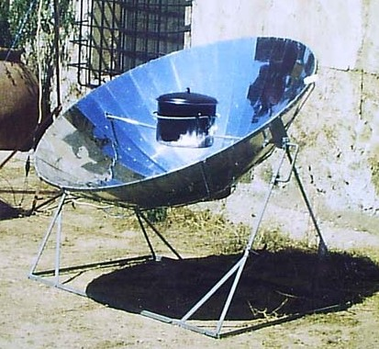
Parabolic boilers are large shaped solar cookers that uses a parabolic shaped reflector to direct sunlight to a small area for cooking.
Advantages:
Parabolic boilers cover a large reflection area that produces high heat for very efficient cooking. They have a circular base that allows them to track the sun, and can cook multiple types of food. This type of solar cooker is easy to take care of and maintain and similar to a traditional stovetop.
Disadvantages:
Parabolic boilers are very large, but cannot be too small or large. They are difficult to transport and needs to be adjusted perfectly to face the sun so the heat is strong enough to cook the food. They cost more to make than panel cookers and box cookers.

Panel Cooker
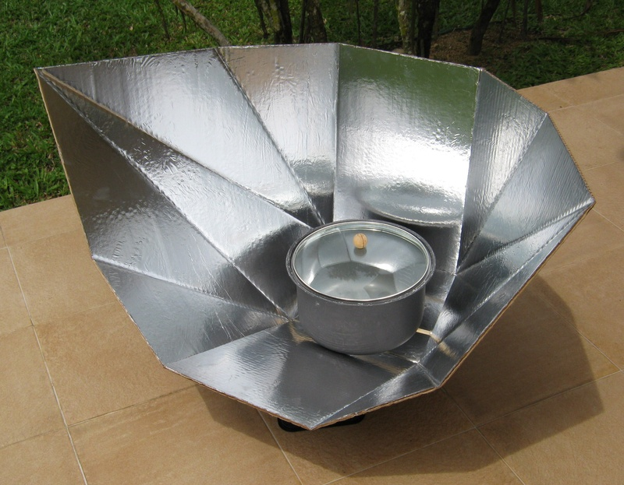
Panel cookers are large shaped solar cookers that incorporate the elements of boxes and parabolic cookers.
Advantages:
Panel cookers are cheap to make, they may be large but are collapsible and easy to transport. They do not require adjustment like the parabolic boiler and is able to cook breads and cakes.
Disadvantages:
Panel cookers are not able to achieve a high temperature like the parabolic boilers; therefore, they cannot fry or grill foods.

Box Cooker
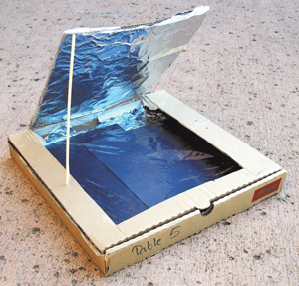
Box cookers are the most popular solar cookers that are used worldwide. There are different ways to make a box cooker.
Advantages:
Box cookers can cook several things at a time, and is created from simple everyday materials. They don’t need to turn to follow the sun while cooking, and is capable of baking bread and cakes.
Disadvantages:
Box cookers are not able to fry food. They might be simple to make, but lacks in reflector areas, which means box cookers aren’t the most powerful. While the sun is lower in the sky, the box may shade the cooking pot inside.

We chose to make the box cooker because it is small, simple, and cheap to make.
Materials:
- Pizza box
- Ruler
- Scissors or utility knife
- Aluminum foil
- Glue
- Plastic wrap
- A sheet of black paper
- A wooden skewer or pencil
Procedure
- Use a knife or sharp scissors to cut a flap in the lid of the box. Cut along three sides of the rectangle, about one inch away from the edge.
- Cover the inner side of the flap with aluminum foil so that it will reflect rays from the sun.
- Tightly stretch plastic wrap over the opening in lid and secure with tape.
- Wrap the inside of the box with aluminum foil, which will reflect rays from the sun. Make sure the shiny side of the aluminum foil is facing down.
- Place a black piece of construction paper at the bottom of the box, on top of the foil. Black absorbs heat, which is where you’re going to cook your food.
- Take the solar oven to a sunny location to cook, be sure to position your oven so the sunlight is reflected from the flap.
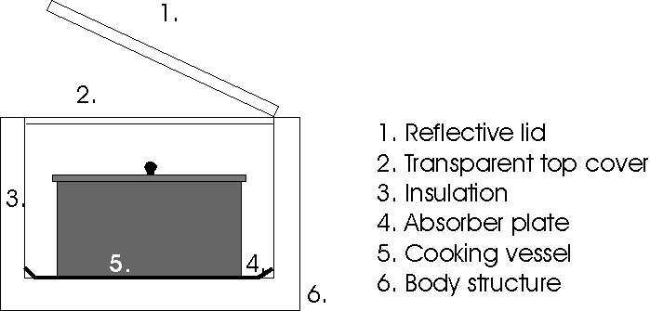
The reflective lid radiates the heat through the transparent top cover into the box. The black sheet of paper absorbs the heat and conducts the heat with the aluminum foil and pot. Heated air inside the box escapes through cracks known as convection.
Results
Trial 1:
Cooked for 3 minutes. Tasted slightly soft is the middle, somewhat chewy, stale, chocolate somewhat melted. 5/10 rating for first smore
Trial 2:
Cooked for 6 minutes. Marshmallow somewhat melted, chocolate melted more and lukewarm, gram crackers became dust when being bit. Tasted a bit similar as first trial but a little bit better. 6/10 rating for second smore.
Trial 3:
Cooked for 12 Minutes. Marshmallow was a lot softer than others, Gram cracker was still dusty and stale. Chocolate was completely melted and warm. Was chewier the others. 8/10 rating for the final smore

Redesigned Solar Oven:
What we could have done to improve our solar oven effectiveness would to be to paint the outside of the box black, so it could absorb the sunlight and keep the inside heated up more. We could have also replaced the aluminum foil with aluminum sheet metal instead since it is easier to heat up and it wouldn’t wrinkle and cause the sunlight to reflect in multiple places rather than 1 spot.
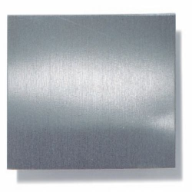
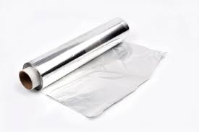
Cites:
http://solarcooking.wikia.com/wiki/Category:Solar_box_cooker_designs
http://solarcooking.wikia.com/wiki/Principles_of_Solar_Box_Cooker_Design
http://solarcooking.wikia.com/wiki/Category:Solar_panel_cooker_designs
https://www.scientificamerican.com/article/sunny-science-build-a-pizza-box-solar-oven/

