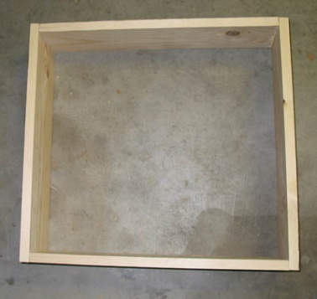
Greenhouse Effect Experiment
Materials:
- Wood board, 1" X 6" X 20" (4)
- Nails, 2 inches long (8)
- Hammer
- Sheet of transparent plastic or glass, 24" X 24", ¼ inch thick.
Has the temperature in your house felt hotter or colder recently? This could be due to the greenhouse effect. What my project is going to be is finding out if creating a model that represents the Earth’s atmosphere would actually effect the temperature like how the greenhouse effect works. What I think is going to happen is that inside the model would be slightly warmer than the outside, or maybe its not. I think though you would need sunlight to make a difference since the green house effect requires sunlight to trap the heat in after the energy passes through. If the temperature outside is higher than what it is inside, it might be because there isn’t sunlight and it is warm on the outside.
To create the model, we need to nail the wood boards together into a frame, put one of the thermometers inside the model and one outside. Cover the plastic sheet over the wood frame and make sure there are no gaps, and place the model outside in a sunny location where it wouldn’t be disturbed. Record the temperature at 3 different times per day, and the weather as well. The greenhouse effect increases the temperature on earth by trapping heat in our atmosphere. It keeps the temperature of earth higher than it would be if direct heating by the sun was the only source of warming. Scientists know that the more CO2 goes into the atmosphere the greenhouse effect would make the Earth warmer causing global warming. From this lab the worst injury you can get is from hammering yourself by accident.
If we didn’t have greenhouse effect the Earth would be too cold for us to live, or any organisms. Or if it causes global warming to increase and make the Earth too hot for us to live comfortably on. I don’t think greenhouse gas would run out or anything that sorts so it would be very sustainable.
Graph below:
Date | Weather | Time | Inside Temp (°C) | Outside Temp (°F)
 |  | 10:00am | -1°C | -2°C
Jan 14th, 2017 | Sunny | 3:00pm | 1°C | 0°C
 |  | 7:30pm | -2°C | -2°C
 |  | 11:30am | 1°C | 0°C
Jan 15th, 2017 | Sunny | 3:00pm | 4°C | 3°C
 |  | 7:00pm | -2°C | -1°C
 |  | 8:30am | 0°C | 0°C
Jan 16th, 2017 | Cloudy/Rain | 3:30pm | 3°C | 2°C
 |  | 8:30pm | 2°C | 1°C
 |  | 8:30am | 5°C | 5°C
Jan 17th, 2017 | Cloudy/Rain | 4:00pm | 6°C | 6°C
 |  | 7:00pm | 6°C | 6°C
 |  | 8:30am | 5°C | 5°C
Jan 18th, 2017 | Mostly Rain | 3:30pm | 9°C | 9°C
 |  | 8:00pm | 6°C | 6°C
 |  | 8:00am | 7°C | 7°C
Jan 19th, 2017 | Cloudy/Rain | 3:30pm | 7°C | 6°C
 |  | 6:00pm | 7°C | 6°C
The recorded information is inconsistent, it’s different depending on the weather and time. It seems like the cloudy/rain days were not as accurate as the sunny days, which there’s only two of. When there is sunlight the information is different from when there is not. Most of the time the temperature inside the box were higher. But occasionally the temperature outside would be higher, I have no idea why, maybe because the frame was a bit crooked so it wouldn’t sit square on the ground.
My hypothesis was mostly right, it was warmer on the inside but not all the time, it depended on different scenarios. What was uncertain was how much the temperature changes, sometimes it looks right but other times it just does things that is different than what was supposed to happen. I couldn’t hammer the frame as well as I’m supposed to so that is one of the downfalls. I was unlucky to have bad weather for the experiment, that’s the confounding variable, and the spot I chose to position the model wasn’t getting as much sunlight as other places. I could have started the experiment a lot earlier than when I started, so I could’ve recorded a lot more data and it would have been more sufficient. I don’t think there’s any other conclusions than what had happened.


 