Name: Tristen Hendriks Blk: D Date: Jan. 6/16

Science 9:GENETIC MODEL

Introduction:
The blueprint for ALL of your cells is found in your cells’ nucleus. In the 1940’s scientists were able to identify the macromolecule that stores the information to make you, well YOU!

Preface:
Using your device find, read, and RE-WRITE in your own words what and who these are:

DNA= deoxyribonucleic acid, is part of all living organisms

DOUBLE HELIX= it is two double stranded molecules that intertwine

NUCLEOTIDE= a compound that has nucleoside. Nucleoside form the basic structure

CHROMOSOME= threadlike structure of nucleic acids and protein in most living cells

CHROMATID= two threadlike strands which a chromosome divides during cell division. Each contains a double helix of DNA

CHROMATIN= Material of the chromosomes of organisms other than bacteria

PURINE= a colorless crystalline compound with basic property

PYRIMIDINE= a colorless crystalline compound with basic property

ADENINE= a compound that is one of the four constituent bases of nucleic acids.

GUANINE= a compound that shows up in guano and fish scales

CYTOSINE= a compound found in living tissues

THYMINE= a compound that is one of the four constituent bases of nucleic acids with pyrimidine derivative

URACIL= a compound found in living tissue as a constituent base of RNA

GENE= something that you would get from your parents DNA

Linus Pauling= he was a chemist, biochemist, peace activist, author, and educator. He also won 2 Nobel Prizes

James Watson & Francis Crick= they jointly won the Nobel Prize in physiology or medicine in 1953 for deoxyribonucleic acid

Erin Chargaff= he was known for his discovery on the double helix structure of DNA

Michael Smith (the Nobel prize winning one)= he won a Nobel Prize in chemistry and was known for site-directed Mutagenesis

DNA’s MODEL TODAY
You now know DNA is made of 3 substances:
1. phosphate
2. sugar
3. nitrogen

How these 3 substances are made is really cool. Paste below a good clear picture of the basic DNA molecule.
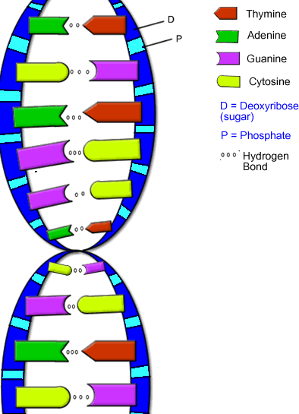

How the purine and pyrimidines are related is cool too. Paste 2 URL of the good videos that show how the adenine, guanine, cytosine and thymine are related to each other.

URL =
http://study.com/academy/lesson/dna-adenine-guanine-cytosine-thymine-complementary-base-pairing.html

URL = https://www.youtube.com/watch?v=ckZEds5taX4

According to most estimates,
the % of the chimpanzee genome that is the same as the human genome: 98.5%
Every persons’ DNA is 99.9% similar to that of another person!
It is the 0.1% differences that give us a unique DNA fingerprint.
Our DNA is organized into chromosomes.
We have 23 chromosomes from each parent, so 46 in total!
DNA is a code for what our body needs to make to survive,
such as proteins, enzymes, and hormones!
We have over 3 billion base pairs in our DNA!
The base pairs that make up DNA bind together to form the classic double helix.
Nearly 2 meters of DNA is located in the nucleus of every cell in our body!

CREATING AN EDIBLE MODEL
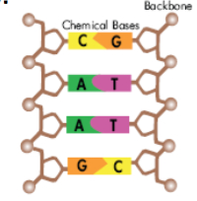
DNA is an abbreviation which stands for deoxyribonucleic acid. DNA is present in all living things. Also, the structure of the DNA molecule is the same in all living things! Your DNA structure is no different than your pet turtle!!! When isolated from a cell and stretched out, DNA looks like a twisted ladder (double helix). The sides of the DNA ladder are called the backbone and the rungs of the ladder are pairs of small chemicals called bases.

There are 4 chemical bases in DNA: Adenine (A) Thymine (T) Guanine (G) Cytosine (C)

A always binds with T, G with C, T with A, and C with G!!!!

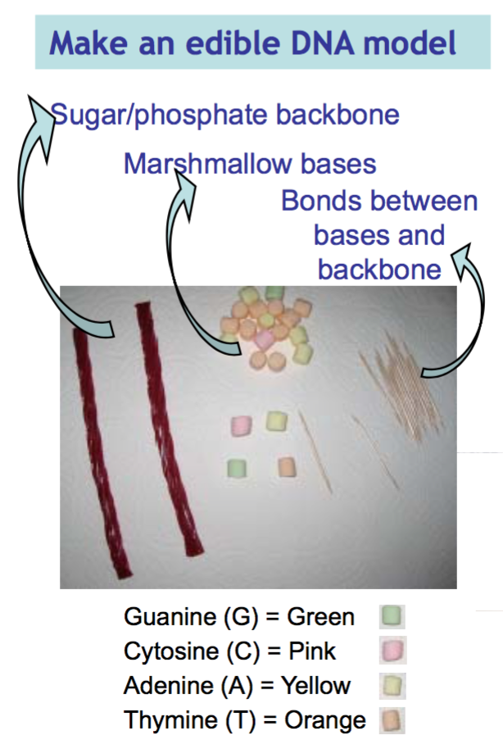
DO NOT GET MATERIALS UNTIL YOU READ THROUGH:
1. Create one DNA strand by attaching the marshmallows with a toothpick to one licorice piece.
• Place toothpicks into the licorice
• Push the marshmallow or fruit onto
the toothpick close to the licorice, leaving enough room for the second matching DNA strand to be attached
• Create the following DNA strand: TAC GTA TGA

2. Add the matching base pairs.
Do you remember how the base pairs partner up?
3. Complete your DNA model. Attach the other backbone (licorice) so your model looks like a ladder.
4. Carefully twist your DNA model so that it looks like a double helix.

Now you need to get the VERY SPECIFIC MATERIALS! Please do NOT grab handfuls of marshmallows.
Materials:
• 2 strands Licorice • 18 Coloured mini marshmallows • 12 Toothpicks
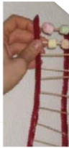
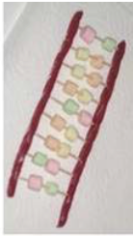

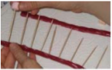
Take a snapshot your double helix and post it on your Edublog.

