My Digital Footprint Article
W
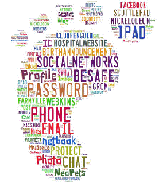
e are living in the 21st century and you never know when some hacker is watching you from your own computer camera. So we have to take extra precautions when operating out computing devices such as our phones, Laptops, Tablets and even TV’s. First of all, what is a digital foot print? Well consider this: anyone, complete strangers included, can tell a great deal about you through your digital footprint. Which is the trail you leave behind when you share updates, post pictures or check into places via social media. It's very likely you're broadcasting what you look like, where you work, where you've been, who you know, what you like to do, and of course, your opinions on a variety of topics. And this can be a reason why so many hackers are getting into systems of companies through your digital footprint. Another thing lots of people may ask is can you clean up your digital foot print. Well it may take some time but it is very difficult you will have to forget about the past and build your self a new and improved digital track it will have to be a lot more appropriate and no faulty images or texts.
From surveymonkey.com
My Digital Foot print may effect my future opportunities by, for example I post something inappropriate on Facebook and my soon to be boss looks up my name on Facebook and looks at my pictures and that may change his mind about hiring me. Also if they simply search up my name on google and if they find something wrong they wont hire me but on the bright side right now I’m clean. Studies have shown that about 90% of companies look up or find your social media profiles and they investigate further into your life and what you are interested in. That’s when they make their decision.
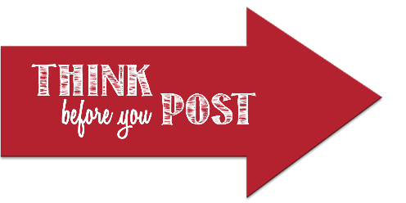
Some tips I would give people is think before you post anything on Facebook, Instagram, Snapchat or anything on the internet let a friend or family member checkout your post to make sure its appropriate. Use a different password for all your accounts on anything. Use Privacy settings to secure all info. Don’t like or share inappropriate pictures because your boss may see what you are doing and may fire you because of that post and there have been reports of co workers, workers and even managers being fired for putting some thing disturbing or offensive on social media posts. Also another very good trick to use is to keep all of your passwords memorised or written out in a small notebook and don’t give them away only if you have too to a family members or trusted friends.
annaisd.org/parents/digital_citizenship/digital_footprint/
The one message that I want to send is that you should all ways be aware of your digital surroundings and never ever post things that are offensive or inappropriate because it will effect your future, career wise, just like I said in the start your boss can look up your name and find all of this information.

