
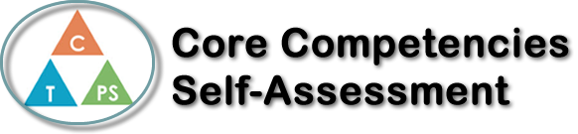
Name: Théa Erickson | Date: September 27, 2017

  How does the artifact you selected demonstrate strengths & growth in the communication competency?  In what ways might you further develop your communication competency? | Self-Reflection  Describe how the artifact you selected shows your strengths & growth in specific core competencies. The prompt questions on the left - or other self-assessment activities you may have done - may guide your reflection process.  In my English 10 class, we did a paragraph about Life experiences and then did a digital version on a Sway. I talked about when my mother and I were in Maui and we went to Molokini Crater and Turtle bay for snorkeling. Through this process of the writing and the Sway, I feel as thought I have improved in the core competency critical thinking – develop and design because in this “Life is about experiences” project I had to experiment with the sway since I never really used it. I also had to keep track of what I was doing and adjust some of the things that I did to get the project the way that I wanted it.  I also feel as though this project has helped me improve my Personal awareness and responsibility – self regulation because in this project I got frustrated at some points because I was having problems with my sway while I was making it and I had to take a moment to think and adjust my plan for my project. I also found this project to be a bit challenging so I had to try my best to figure it out and put all my effort into it.


How does the artifact you selected demonstrate strengths & growth in the thinking competencies?

In what ways might you further develop your thinking competencies?


How does the artifact you selected demonstrate strengths & growth in the personal & social competencies?

In what ways might you further develop your personal & social competencies?

Publish Your Self Assessment
You will now attach and/or embed your self-assessment to the bottom of the blog post with the artifact you have chosen. You may choose to make this post private or public. After placing your artifact on a blog post, follow the instructions below.
- Categories - Self-Assessment
- Tags - Now tag your post using the tag that corresponds to the competency that you have written about. You can choose more than one. Please use lower case letters and be exact.
  - #creativethinkingcc
  - #communicationcc
  - #criticalthinkingcc
  - #socialresponsibilitycc
  - #personalidentitycc
  - #personalawarenesscc
- Use the Add Document button located at the top of your post page and embed your self-assessment at the bottom of your blog post.
- Publish

