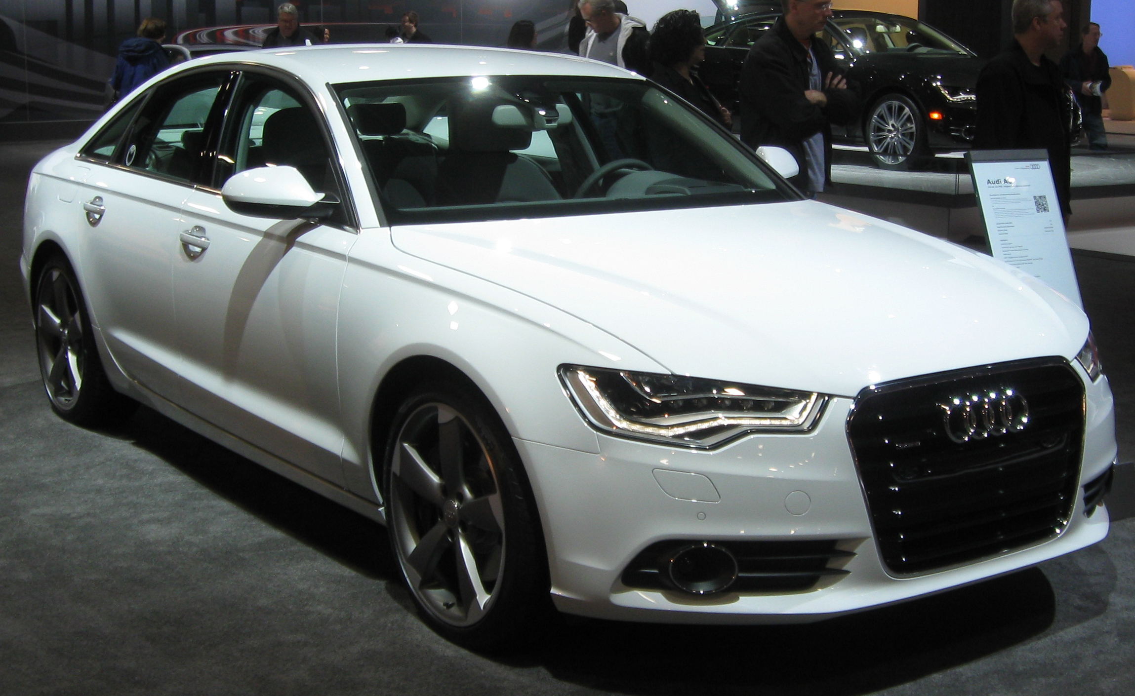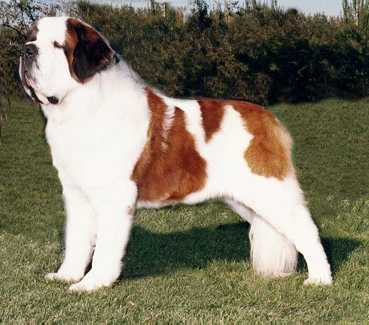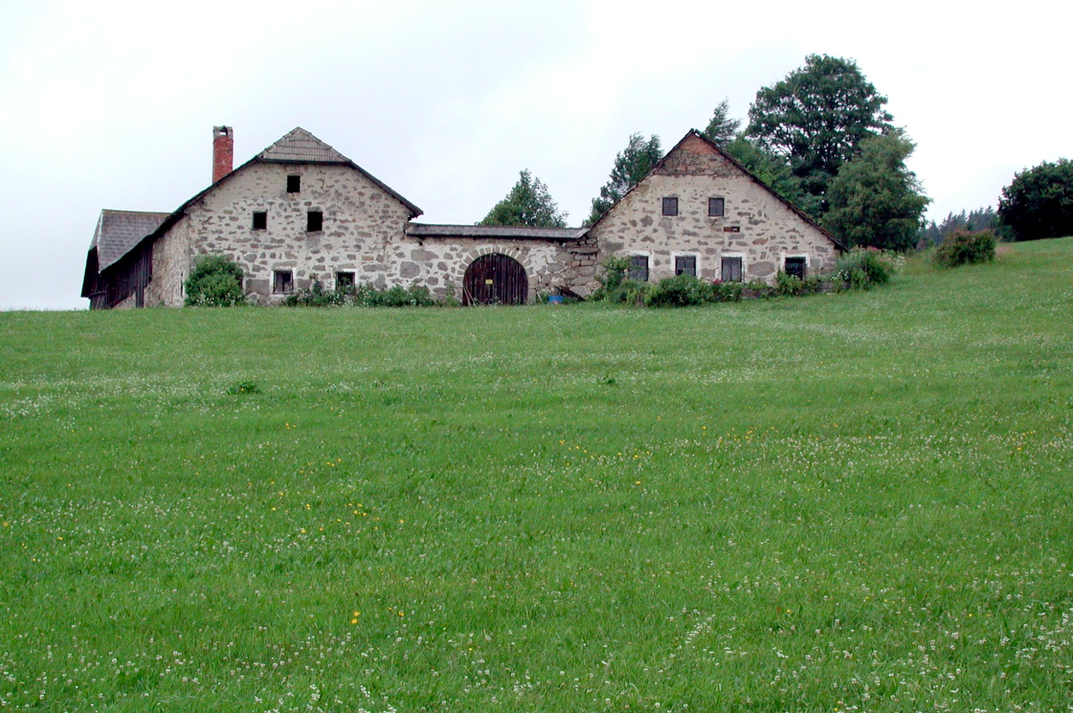My transportation price is about 36-46 thousand dollars. My home, not very new but still beautiful would probably be about a million to buy by looking at the amazing yard size. My companion, my saint bernard will probably be about 4 thousand dollars. I want to live a regular life but have money to travel and keep up on my resources without struggle. Ferrets, I want to have two. The cost of them plus cage etc should be about a thousand dollars. Vet costs for my animals could be about 2 thousand also.

