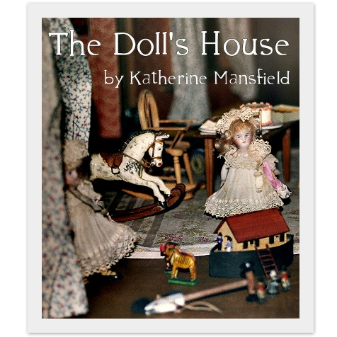
The Doll’s House
This story was written in 1922. The author, Katherine Mansfield, grew up in rural New Zealand and that is where this story takes place. It is a story about class conflict and the cruelty between children. It is also illustrates how class barriers are artificial and destructive to social relationships.
Vocabulary: Find 6 words to put on your bookmark for your logophile. This includes: word, the sentence from the book, part of speech, definition, showing sentence. You can choose ANY six words from the story.
- Congeal- “There was actually a tiny porch, too painted yellow, with big lumps of congealed paint hanging along the edge.” Pg. 164
  - Verb- to solidify- The blood congealed into a solid mass that stuck to the carpet.

Prewriting: What is class discrimination? Do you think there are class divisions in Canada? In what way is Canada divided socially?

To Record:
- What conflict is the main conflict in this story? (refer to prewriting question) Explain in a paragraph.

- There are three symbols in this story: the dollhouse, the lamp and Kezia herself. What do they represent? Use point form.

- The story is told from the omniscient point of view. What advantage does the writer have in using this point of view rather than first person point of view?

- Who is the protagonist and who is the antagonist? Are they dynamic or static? Refer to the “short story terminology” for a definition.

- What is the theme of this story? Create a theme statement….

- Can you develop an inquiry question?

Reading Response: Choose ONE of the following:
- Improvise a short conversation between mother and Kezia as her mom tries to explain why Kezia should have nothing to do with the Kelveys. (dialogue form {play} or a paragraph)
- What are some ways in which children such as the Burnells might be taught not to be prejudiced?

