“Fear Photo”
- TAG: Fear
- In your group, go to the TAG and look up the images.
- All three of you should be looking at the same image.
- Explain the image. How does it portray “fear”?
- How does/has this fear (as portrayed in the image) affected your actions? Your decisions?
- How can it be used against you?
- How can you minimize this power?
- Do others see the same thing in this image?
- What may be other perspectives in viewing this image? Do we all see the same thing?
- Do we have the same fear?
- Is there anything in common between you three?
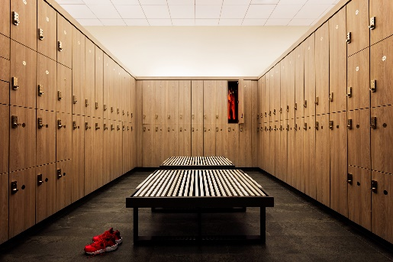
Questions to ask the photographer. Choose what interests you.
- Why did you take the image at this angle? Or perspective?
- Did you know right away what image you were going to capture, or did you really have to think about your fears?
- Does anyone else share this fear?
- Are there things missing that you cut out of the frame purposely? Or that you could not fit in the frame? What were they?
- If I had the same fear, I would have taken a photo of __________________.
- If you could add more details to this image, what would you add? Or take away?

Explanation (under your image on the blog OR in One Note under “Essential Question”)
If you are uncomfortable sharing this information on your blog, you may write it in your One Note under “Essential Questions”.
- Write an explanation of your image. Fill ME in on how your image portrays your fear. Then, tell me how this fear affects your actions and how it can be used against you. What are you doing to reduce that power over you? Did you learn anything from this exercise? About yourself or others?

