Indian Education: A Short Story
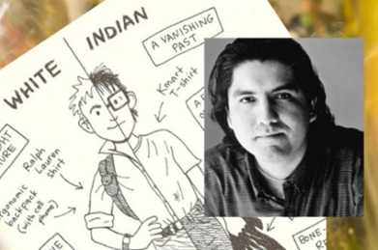
Background: Sherman Alexie, the son of a Coeur d’Alene Indian father and a Spokane Indian Mother, was born in 1966 and grew up on the Spokane Reservation in Wellpinit, Washington. This is home to some 1,100 Spokane tribal members. He endured much teasing from his fellow classmates on the reservation. He realized as a teenager that his educational opportunities there were extremely limited, so Alexie made the unusual decision to attend high school off the reservation in nearby Reardon. While in college, he began publishing poetry, short stories and numerous novels including The Absolutely True Diary of a Part Time Indian. Alexie also wrote the screenplay for the highly acclaimed film Smoke Signals.
Native American History in the USA:
"A great general has said that the only good Indian is a dead one," Pratt said. "In a sense, I agree with the sentiment, but only in this: that all the Indian there is in the race should be dead. Kill the Indian in him, and save the man." Army Officer Richard Pratt, 1892. Founder of Native American boarding schools in the USA
“’At boarding schools, the curriculum focused mostly on trades, such as carpentry for boys and housekeeping for girls. "It wasn't really about education," says Lucy Toledo, a Navajo who went to Sherman Institute in the 1950s. Toledo says students didn't learn basic concepts in math or English, such as parts of speech or grammar.” (NPR.org)

Pre-discussion/prewriting:
- What is your most positive school experience and what is your worst? Which memories dominate?
OR
- Describe what you already know about First Nations and discrimination in Canada. You can use point form- no more than 10 points.

Reading Skill: Write all over your story. Read actively. Visualize, connect, question, make notes on meaning, notice writing style, etc.

Short Story Terms:
Term | Answer | Significance/Explanation
point of view
central conflict of the story
Is the protagonist a dynamic or static character?
His hair is a symbol. What does it symbolize?
Describe the irony in paragraph 67 and 68. | (Type of irony)

Questions on meaning:
- What overall impression (both positive and negative) does Alexie create of life on the reservation? Point to specific examples in the text that contribute to this impression. Why do you think Alexie chose to show both sides?

- Notice those places in the essay where Alexie describes how Native Americans face prejudice and negative stereotyping. What does this focus suggest about his purpose?

- What is the significance of the double meaning of the title of the story?

- Theme statement: (Topic + treatment +/- = result)

- Change the theme statement into an inquiry question.

Writing Analysis:
- In this essay, Alexie offers thirteen scenes: one for each school grade and a postscript reunion. Why do you think he set these scenes up in separate sections and labelled them with headings, instead of, say, running the sections together and introducing each with a phrase like “During the first grade…”. What is the EFFECT of Alexie’s narrative technique?

- Each section of the essay ends with a brief paragraph, usually a single sentence. What common FUNCTION do all these conclusions perform?

- At several points in the essay, Alexie uses compare and contrast. Locate two examples and explain what each contributes to the essay.

Post-writing:
Comment on the Macleans article. What is the main message of http://www.macleans.ca/news/canada/out-of-sight-out-of-mind-2/

