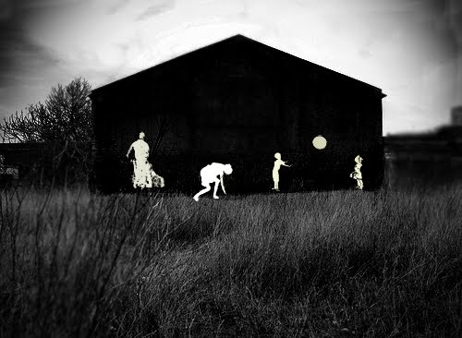
There Will Come Soft Rains
"He's always been a writer who wanted to improve the human condition by showing the way people really behave…. He's not interested in rocket ships and ray guns except as a means of putting people in a different milieu." Ben Bova (author of “Mars and Venus”) www.raybradbury.com/articles_peoria.html
Focus Concepts: irony, theme, mood
Prewriting: In a head to head battle, who would win? Mother Nature or Father Machine? Describe this battle including weaponry and strategy. (copy your answer into OneNote)
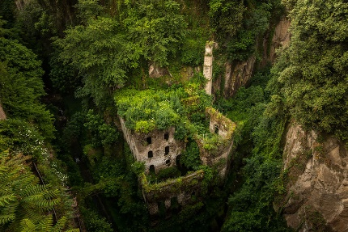
Image credit: Jason Wallace
Image credit:www.messynessychic.com

Reading Strategies: visualization, connecting, questioning/inferring, transforming
To discuss with your group then answer in writing:
- In the second paragraph of the story, the author indirectly states what has happened. What disaster do you believe just occurred?

- Once the audience is aware of the disaster, what is the intent of the author when he goes into such detail describing the house?

- There are no characters in this story. What effect does this have on the “mood” that is created? Explain.

- Bradbury gave the house human characteristics as it burned. Why? Describe the personification he uses.

- What is the relevance to the poem “There will come soft rains” to the story?

- What type of irony is present in this story? Explain it.

- What is the theme of the story? Write a theme statement for this story.

- Can you create an inquiry question that works with the theme of this book?

Post writing: -choose ONE of the following three options and write in the OneNote for our class.
Choose TWO of your questions (stickies) and write out the quote AND your question. Then, answer with a MAYBE. (This is questioning and inferring as reading strategies)
OR Comment on the theme. Do you think Ray Bradbury is right? (Transformation reading strategy)
OR Can you think of another story/movie that has a similar theme? Explain the connection.

