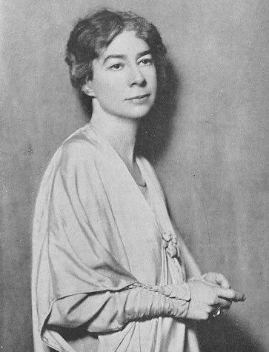
“There Will Come Soft Rains” by Sara Teasdale (1920)

There will come soft rains and the smell of the ground,
And swallows circling with their shimmering sound;
And frogs in the pools singing at night,
And wild-plum trees in tremulous white;
Robins will wear their feathery fire,
Whistling their whims on a low fence-wire;
And not one will know of the war, not one
Will care at last when it is done.
Not one would mind, neither bird nor tree,
If mankind perished utterly;
And Spring herself, when she woke at dawn
Would scarcely know that we were gone.

- Find the poetic devices: alliteration, assonance and personification
- Look for imagery (the five senses).
- Comment on her use of imagery with nature and then with humans.

- Where does the tone change?
- This poem is “euphonic”. What does this mean? Explain.

- What is the message of this poem?

