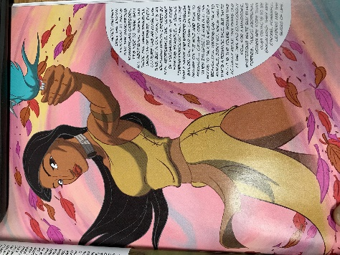
“Rising Above” by Steven Keewatin Sanderson
- The author writes that there are both positive and negative stereotypes of Aboriginal people. Explain in your own words what a positive stereotype is and use examples from the text to show why it is harmful.

- Select one panel of this graphic story and explain how it communicates its message visually. Consider the artist’s choices such as the size and shape of the panel; colour; the character’s age, gender, and facial expressions; setting and speech bubbles. (Eg. On page 41, there are three smaller panels in the middle of the page. I notice that he keeps these images smaller, almost like he is most ashamed of these because they are the negative stereotypes. He uses darker colours to show the mood and little dialogue. Maybe he feels the images are enough to portray the idea? The facial expressions look mean or desperate, just like the stereotypes.)

- How does the narrator feel about the stereotype of the “noble savage”? Choose the best answer from the following list and highlight it:
  - He feels the stereotype is the closest to what Aboriginal people are really like.
  - He feels proud that people have an image of Aboriginal people as strong, stoic hunters.
  - He feels the stereotype traps Aboriginal people in the past, like in a museum.
  - He feels this stereotype unfairly represents Aboriginal people as simple hunters.
- How effective is this graphic story in exploring the topic of stereotypes and identity? Do you like graphic stories as opposed to an opinion piece? Or a short story? Or a TedTalk?

