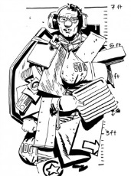
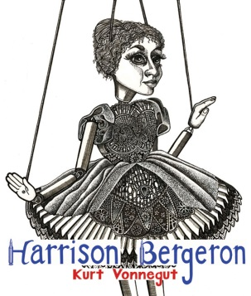
“Harrison Bergeron” by Kurt Vonnegut
A dystopia is defined as a seemingly utopian society with at least one fatal flaw; in Vonnegut’s "Harrison Bergeron", the setting is "a ruthlessly egalitarian society, in which ability and accomplishment, or even competence, are suppressed or stigmatized as forms of inequality”. This story was published in 1961, when the USA was still engaged in a Cold War with Communist Russia. This story satirizes the idea of a perfect, equal society that many societies strive to achieve.
Literary Concepts: satire, dystopia/utopia, symbolism, irony, theme
A. Vocabulary. Define the following words:
1. dystopia
2. utopia
3. egalitarian
4. satire
B. Discuss the meaning of the Calvin and Hobbes comic below
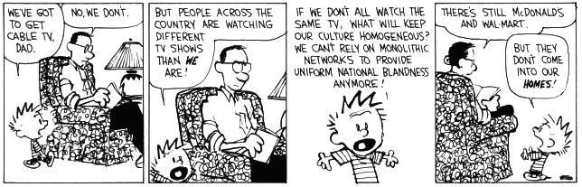
C. Prewriting:
Prewriting- Write a short paragraph outlining what you think would be a utopian society

D. Reading Strategies: questioning, visualizing, inferring.
Read the story using the above strategies.
E. To Discuss In Your Groups- There is no need to write it down:
- Discuss the role of TV in this story. What is Vonnegut trying to say about the use of TV in our society?
- Track the different sounds that George hears. Describe each sound in order and discuss its significance. They are NOT random sounds.
- Do you think that the death of Harrison was staged by the H-G?
- If Harrison was able to declare himself emperor, how do you think he would have changed society? Would it be better, worse or the same?
- What “handicaps” are imposed on people today? Are all talented people able to explore and show their talent? Discuss.
- The characters in the story are meant to symbolize “types” of people in American society. Describe who the Handicap General, Harrison, George and Hazel all signify.
F. To Record:
- Discuss the role of TV in this story. What is Vonnegut trying to say about the use of TV in our society?

- The characters in the story are meant to symbolize “types” of people in American society. Describe who the Handicap General, Harrison, George and Hazel all symbolize.

- What is the main conflict in this story? Explain.

- What is the story’s point of view? Why do you think Vonnegut used this one?

- Using examples from the story, explain how “Harrison Bergeron” is a satire.

- What is a possible theme of this story? Put it into a theme statement.

- Can you propose 1-2 inquiry questions for this story?

Reading Response: Choose ONE to answer in a detailed, insightful response
- We live in a world of discrimination based on inequality, intolerance and ignorance. Do you think we can ever stop discrimination based on inequality? What is stopping us? How can we stop it? OR
- “He should get a nice raise for trying so hard.” Should people be paid based on effort or ability?

